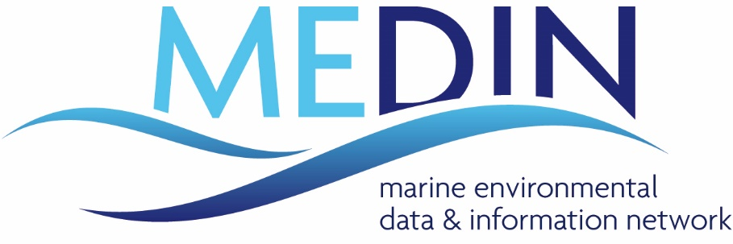
The Marine Environmental Data and Information Network (MEDIN) was established in April 2008 to make access to, and analysis of, marine data easier and cheaper for the good of all users of the marine environment and wider society.
MEDIN are currently looking to assess the value of the services we provide to the marine community and we need your help!
Please fill in this short survey, which will only take around 10 minutes to complete.
The survey is designed to gather information on how people use MEDIN’s services and how you benefit from them. Your help is gratefully received and will be used to improve the future services provided by MEDIN. The feedback you give will enable MEDIN to determine just how valuable a service we provide to the UK marine community.
MEDIN have commissioned Economics for the Environment Consultancy (eftec) to undertake this assessment. All responses will be kept confidential and MEDIN do not ask for your name or the name of your organisation.
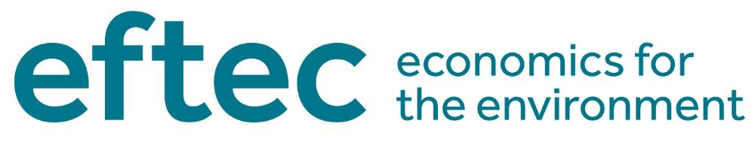
The survey will remain online until 13th September. eftec will then analyse the results and provide MEDIN with a final report on the benefits of MEDIN at the end of October.
Please note, there is no intention to use this information to make MEDIN a paid service, it is solely to better understand the benefits that we provide.

