MEDIN Joint Working Group Meeting  November 2020 | Paper P2
Information Paper | This document is the MEDIN Annual Report for 2019-20 and has been approved by the MEDIN Sponsors.  The MEDIN Working Groups are asked to check for any inaccuracies before the report gets circulated to all MEDIN partners and the Marine Science Coordination Committee.  Minor comments should be submitted as track changes to the document to Clare Postlethwaite (cfpo@noc.ac.uk) by 30th November.  Thank you to all members of the MEDIN Working Groups who have contributed to a successful year.

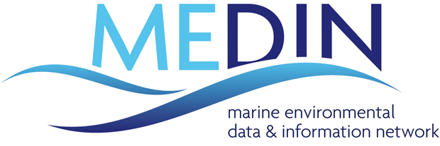Annual Report
2019-2020

‘measure once, use many times’

2019-20 was the first year of the Marine Environmental Data and Information Network’s (MEDIN) ambitious five-year (2019-24) Business Plan. MEDIN is strengthening and evolving as the leading authority on the management of marine environmental data, albeit with a reduced level of funding, down from £763K per year before 2011 to £507K in the last year. The funding situation for 2019-20 was rather uncertain for MEDIN until late in the financial year, which necessitated mitigating steps including postponing some activities until future years. Nevertheless, MEDIN successfully delivered the bulk of its planned work, as can be seen in this report.

The 2019-24 MEDIN Business Plan was developed around 3 strategic goals, which encompass MEDIN’s vision for all UK marine data to be Findable, Accessible, Interoperable and Reusable (FAIR). MEDIN has defined 7 Key Performance Indicators (KPIs) based on these strategic goals. 2019-20 provides the baseline for these KPIs, which will be monitored throughout the duration of the Business Plan and used to define targets for future years. These baselines point to some interesting findings.
- Our partners are predominantly from the policy and commercial sectors and cover all regions of the UK.
- The MEDIN portal is our most frequently used tool.
- The number of datasets signposted from the MEDIN portal increased by 3% during 2019-20 and 64% of those datasets are archived at our accredited Data Archive Centres (DACs).
- Our social media campaigns and attendance of conferences and trade fairs gives us wide communication reach.
- Our training workshops attract attendees predominantly from the policy, commercial and academic sectors.
- Perhaps most significantly, this year we demonstrated that the benefits of our services far outweighs the cost of providing them.

Strategic Goal A: MEDIN delivers its vision for all of the UK marine community by providing tools and services beneficial across the wide spectrum of the marine data community and the full data lifecycle; ensuring widespread archiving and open access to high-quality data to enable maximum use and security and to provide integration and coordination of services.
We have 2 Key Performance Indicators which measure progress against this goal:
KPI 1: Number of active MEDIN partners,
KPI 2: Number of users of MEDIN tools and services.
How did we perform this year?
57 partner organisations | 5287 users

Strategic Goal B: MEDIN delivers the technical infrastructure required to ensure UK marine environmental data are Findable, Accessible, Interoperable and Reusable (FAIR) by providing: a coordinated network of marine Data Archive Centres; a single portal to access all UK marine data; and standards, tools and services to support the UK marine community.
We have 2 Key Performance Indicators which measure progress against this goal:
KPI 3: Summary of access to data described in the MEDIN portal,
KPI 4: Number of requests for data at MEDIN Data Archive Centres.
How did we perform this year?
64% data available from MEDIN portal is archive quality | 950,000 requests for data

Strategic Goal C: MEDIN delivers an open and constructive data management culture: fostering global collaboration and partnerships; addressing skills gaps; providing training and education.
We have 3 Key Performance Indicators which measure progress against this goal:
KPI 5: Number of people receiving regular MEDIN updates,
KPI 6: Number of organisations receiving MEDIN data management training
KPI 7: Number of national and international conferences or trade fairs where MEDIN is represented.
How did we perform this year?
1,507 update recipients | 31 organisations receiving training
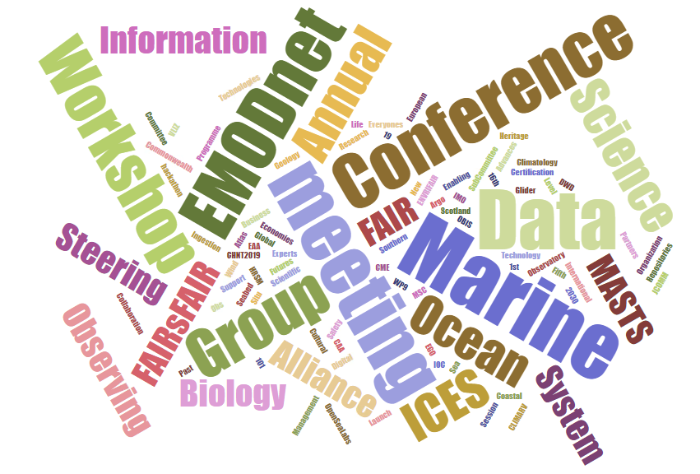
40 events where represented

Available funds
MEDIN is a collaborative initiative that attracts sponsorship from like-minded organisations that recognise the scientific, environmental and financial benefits of providing a coordinated, national framework for managing the UK’s valuable and unique marine data resources. £569,917 was available to fund MEDIN activities in 2019-20: £507,000 from the consortium of 15 sponsors, in addition to £62,917 carried over from previous years.

Sponsor Name | Funding level for 2019-20
DEFRA: Department for Environment Food and Rural Affairs | £175,000
NERC / NOC: Natural Environment Research Council / National Oceanography Centre | £131,000
Scottish Government | £80,000
BEIS: Department of Business, Energy and Industrial Strategy | £30,000
UK Hydrographic Office | £19,000
Cyfoeth Naturiol Cymru / Natural Resources Wales | £14,000
Met. Office | £14,000
The Crown Estate | £7,000
Maritime and Coastguard Agency | £7,000
CEFAS: The Centre for Environment, Fisheries and Aquaculture Science | £5,000
Joint Nature Conservation Committee | £5,000
OceanWise | £5,000
DAERA: Department of Agriculture, Environment and Rural Affairs, Northern Ireland | £5,000
AFBI: Agri-Food and Biosciences Institute | £5,000
Welsh Government | £5,000
TOTAL available to MEDIN from sponsorship funding | £507,000
Carry over from previous years | £62,917
Final Total available for 2019-20 | £569,917

Expenditure
MEDIN is split into seven Work Streams (WS), each with its own budget and project manager, to allow efficient delivery and management of MEDIN’s programme of work. We spent £480,054 during 2019-20: £281,340 on the employment costs of the MEDIN project managers (the MEDIN Core Team) including all individual and organisational overheads, £15,325 on travel and subsistence costs and £183,389 on external contract costs required for the operation, maintenance and development of the MEDIN framework.

Expenditure category | Expenditure in 2019-20 | Work Stream | Expenditure in 2019-20
Employment Costs of Core Team | £281,340 | WS1: Data Archive Centres | £113,659
Travel and Subsistence | £15,325 | WS2: Standards | £93,167
External Contracts | £183,389 | WS3: Portal | £77,607
 |  | WS4: International Links | £21,002
 |  | WS5: Resources and Applications | £8,603
 |  | WS6: Communications | £34,386
 |  | WS7: Management and Coordination | £108,388
 |  | Special Projects | £23,243
TOTAL expenditure | £480,054 | TOTAL expenditure | £480,054

End of year balance
This year saw uncertainty in MEDIN’s overall funding level until very late in the year. We saw an increase in funding from the UK Hydrographic Office, a decrease in funding from Scottish Government, a new sponsor in the Welsh Government and a severe delay in funding confirmation from the Department for the Environment, Food and Rural Affairs (Defra), MEDIN’s biggest financial contributor. To mitigate risk from this uncertainty, we postponed some of our planned activities until future years, which resulted in an end-of-year underspend of £89,863 for 2019-20.

External expenditure
This year MEDIN spent £183,389 on external contract costs required for the operation, maintenance and development of the MEDIN framework.
Supplier | Item | Cost
BGS | DAC costs 2019-20 | £11,000
BODC | DAC costs 2019-20 | £11,000
DASSH | DAC costs 2019-20 | £13,200
UKHO | DAC costs 2019-20 | £13,200
Met Office | DAC costs 2019-20 | £13,200
Fish DAC CEFAS | DAC costs 2019-20 | £6,600
Fish DAC Marine Scotland | DAC costs 2019-20 | £6,600
Historic Environment DAC ADS | DAC costs 2019-20 | £4,404
Historic Environment DAC HES | DAC costs 2019-20 | £3,670
Historic Environment DAC RCHAMW | DAC costs 2019-20 | £3,670
Multiple suppliers | Meeting costs | £405
Multiple suppliers | Courier costs | £20
 | Total WS 1 expenditure | £86,969
DASSH | Standards Working Group Support | £12,837
HR Wallingford | Metadata Maestro and MEDIN Schematron update | £18,000
Multiple suppliers | Meeting costs | £388
Multiple suppliers | Workshop costs | £370
Phoenix | XML editor | £99
 | Total WS 2 expenditure | £31,694
MARIS | UKDMOS Portal Maintenance 01/05/19-01/05/20 | £1,800
BODC | MEDIN product hosting and support | £5,000
NOC | Website hosting and support | £5,000
MARIS | MEDIN portal and catalogue hosting and maintenance Jan 2019-Dec 2019 | £9,720
MBA / DASSH | MEDIN Helpdesk April-Sept 2019 | £8,727
Multiple suppliers | Telephone costs | £14
 | Total WS 3 expenditure | £30,261
Multiple suppliers | Meeting costs | £514
 | Total WS5 expenditure | £514
4Imprint Ltd | Materials for workshops/ outreach events (bottles, pens) | £776
DIGIRU | Materials for workshops and outreach events (500 leaflets, 400 business cards, 200 standards fliers) | £212
MASTS Annual Science Meeting | Conference fee | £380
CMS | Sponsorship of Coastal Futures including conference fee and trade stand | £690
Multiple suppliers | Courier costs | £37
 | Total WS6 expenditure | £2,095
OceanWise | Representing MEDIN at PSEG Dec 2019 | £570
DASSH/MBA | Representing MEDIN at HBDSEG and BioDIG meetings | £3,540
Professor Peter S. Liss | Chairing MEDIN, representing MEDIN at MSCC and MARG | £7,560
Multiple suppliers | Meeting costs | £205
Multiple suppliers | Telephone costs | £20
 | Total WS7 expenditure | £11,894
eftec | Cost Benefit Analysis of MEDIN | £19,782
Bob Earll CMS | Distributing Cost Benefit Analysis Survey | £180
 | Total special project expenditure | £19,962

Governing Body
MEDIN was established in 2008 as a collaborative, cross-sectoral initiative for public good. Our governing body, the MEDIN Sponsors’ Board, comprises one member from each funding organisation, ensuring each funder has the opportunity to influence our national and international work. The Board is responsible for defining the strategic direction of MEDIN, approving work programmes and budgets. Professor Peter Liss CBE FRS chairs the MEDIN Sponsors’ Board, which met twice during 2019-20.
Sponsor Name | Sponsors’ Board member 2019-20
DEFRA: Department for Environment Food and Rural Affairs | Sofiya Stoyanova
NERC / NOC: Natural Environment Research Council / National Oceanography Centre | Dr. Graham Allen
Scottish Government | Dr. Jens Rasmussen
BEIS: Department of Business, Energy and Industrial Strategy | Saravanan Marappan
UKHO: UK Hydrographic Office | James Carey
Cyfoeth Naturiol Cymru / Natural Resources Wales | Helen Wilkinson
Met. Office | Jon Turton
The Crown Estate | Chelsea Bradbury
Maritime and Coastguard Agency | Paula English
CEFAS: The Centre for Environment, Fisheries and Aquaculture Science | Laura Hanley
JNCC: Joint Nature Conservation Committee | Elly Hill
OceanWise | John Pepper
DAERA: Department of Agriculture, Environment and Rural Affairs, Northern Ireland | Colin Armstrong
AFBI: Agri-Food and Biosciences Institute | Dr. Matt Service
Welsh Government | Shelley Vince
Chair | Professor Peter Liss CBE FRS

Operational Groups
Our Board is supported by an Executive Team, which provides interim guidance and management of our operational work programme between Sponsors’ Board meetings. The Executive Team is made up of four sponsor members (DEFRA, NERC/NOC, Scottish Government and a fourth member, currently UKHO, as voted by the Sponsors’ Board), three subject experts (the chairs of the MEDIN Working Groups) and the MEDIN work stream managers. Our Executive team met four times in 2019-20.
Executive Team member | Sponsor/Expert member | Executive Team member | MEDIN work stream member
Sofiya Stoyanova (DEFRA) | Sponsor member since 2019 | Dr. Clare Postlethwaite | Since 2012
Dr. Graham Allen (NOC/NERC) | Sponsor member since 2014 | Dr. Robin McCandliss
Dr. Jens Rasmussen (Scottish Government) | Sponsor member since 2019 | Dr. Sean Gaffney | Since 2014
James Cooke (UKHO) | Sponsor member since 2017 | Dr. Gaynor Evans | Since 2008
Jon Parr (MBA) | Expert member since 2008 | Charlotte Miskin-Hymas
Graeme Duncan (JNCC) | Expert member since 2019 | Roseanna Wright
Dr. Mike Osborne (OceanWise) | Expert member since 2008
Professor Peter Liss CBE FRS | Chair since 2008

The seven MEDIN work streams are project managed and supported by the MEDIN Core Team - seven part-time staff employed by the National Oceanography Centre within the British Oceanographic Data Centre. In addition to project management, the MEDIN Core Team provide leadership for the work streams and secretariat as well as administrative support to MEDIN. The MEDIN Core Team met monthly in 2019-20.
Core Team member | Work Stream (WS) role
Dr. Robin McCandliss | Lead on DACs WS
Roseanna Wright | Lead on Standards WS
Dr. Sean Gaffney | Support to Standards WS
Dr. Gaynor Evans | Lead on Portal, Products and Services WS
Dr. Clare Postlethwaite | Lead on International; Resources and Applications; and Management and Coordination WS
Charlotte Miskin-Hymas | Lead on Communication WS and support to International WS
Paul McGarrigle | Administrative Support
Dr. Clare Postlethwaite | Coordinator since 2014

Working Groups
Our partners help deliver our strategic goals by participating in our working groups, which met regularly throughout 2019-20.
DAC Working Group | Standards Working Group | Portal Steering Group | Resources and Applications Working Group
Archaeology Data Service (ADS) | BGS | DASSH | ABPmer
British Geological Survey (BGS) | BODC | Marine Scotland | Marine Management Organisation
British Oceanographic Data Centre (BODC) | Cefas | NRW | NRW
Centre for Environment, Fisheries and Aquaculture Science (Cefas) | DASSH | OceanWise | OceanWIse
DASSH | Joint Nature Conservation Committee (JNCC) | UKHO
Department for Environment, Food and Rural Affairs (DEFRA) | Natural Resources Wales (NRW)
Historic Environment Scotland | OceanWise
Marine Scotland | Scottish Association for Marine Science
Met Office | SNH
Royal Commission for the Ancient and Historic Monuments of Wales (RCHAMW) | The Crown Estate
Scottish Natural Heritage (SNH) | UKHO
Jon Parr (Marine Biological Association)  Co-chair since 2008 | Graeme Duncan (JNCC)  Co-chair since 2019 | Dr. Gaynor Evans (MEDIN)  Chair since 2008 | Dr. Mike Osborne (OceanWise)  Chair since 2008
Dr. Robin McCandliss (MEDIN)  Co-chair since 2017 | Dr. Sean Gaffney (MEDIN)  Co-chair 2014-2019  Roseanna Wright (MEDIN)  Co-chair since 2019

Parent Body
The Marine Science Coordination Committee (MSCC) is the parent body for MEDIN, providing strategic direction, which MEDIN uses to define its high-level goals. MEDIN reports to MSCC through this annual report and shorter progress updates as requested.

Administrative Body
The management and operation of MEDIN is administered by the National Oceanography Centre (NOC), on behalf of the MSCC.

The MEDIN Data Archive Centres (DACs) provide the cornerstone for long-term management of UK marine data and the 'collect once, use many times' philosophy. The benefits of having a coordinated network of DACs and reusing data helps to avoid duplication of primary data gathering efforts, brings time savings through organisations not having to manage their own data (better formatting and storage), and contributes to the drive towards making data Findable, Accessible, Interoperable and Reusable (FAIR). Currently 64% of the data accessible from the MEDIN portal are considered “archive quality”. In other words, they are managed, quality controlled and disseminated by one of our accredited Data Archive Centres.

Our DACs provide
- Secure, long-term curation of key marine data sets, according to best practice and to relevant national and international standards.
- Clear, searchable information on their data holdings by the generation and publication of metadata on the MEDIN portal.
- Open and easy access to their data, wherever possible.
- The first point of call for expertise in the management of marine data.
The DACs cover a wide spectrum of data within the marine environment, including bathymetry; fish and shellfish, fisheries, aquaculture and related samples; the historic environment; marine geology and geophysics; marine species and habitats; marine meteorology; water column oceanography. This network provides users with a safe place to deposit and access data for the long term.

We provide direct access to UK marine data
We promote open and easy access to marine data. Our DACs continue to develop their systems and processes to make it as easy as possible to access the data they manage. This year we continued to improve direct access to data, whereby a user can access data from the MEDIN Portal within ‘2 clicks’. Four of our DACs now provide direct access to over 80% of their data holdings. In total, 40% of the data held in our DACs are available to download or use within ‘2 clicks’ of finding it, without needing to register, login or carry out additional searches. This figure remains under 50% unfortunately as UKHO, who manage over 4,000 of the data sets in the MEDIN portal, have been unable to make progress with this initiative this year.
MEDIN’s accredited Data Archive Centres
ADS | Archaeology Data Service
BGS | British Geological Survey
BODC | British Oceanographic Data Centre
Cefas | Centre for Environment, Fisheries and Aquaculture Science
DASSH | Archive for Marine Species and Habitats Data
HES | Historic Environment Scotland
Met Office
MSS | Marine Science Scotland
UKHO | UK Hydrographic Office
RCAHMW | Royal Commission for the Ancient and Historical Monuments of Wales

Figure 1: Percentage of each Data Archive Centre’s datasets directly accessible within “2 clicks” of finding them on the MEDIN portal.

We move to international accreditation
MEDIN led the way in developing an accreditation scheme for marine data centres in 2008. Our accreditation process was adopted or incorporated into international accreditation schemes such as the Intergovernmental Oceanographic Commission’s International Oceanographic Data and Information Exchange (IODE). This year we decided to transition to the Core Trust Seal (CTS), an internationally recognised standard, as the required accreditation for MEDIN DACs. Two of our DACs have already achieved their CTS accreditation (BGS and ADS) and others have started the process (HES, UKHO, BODC). CTS is a natural extension of MEDIN accreditation and allows our DACs to broaden their international reputations, further highlighting them as approved, trusted repositories.

We improve provenance of our data holdings
The provenance of data is a record of the people, organisations and activities involved in producing, influencing, or delivering that data. In particular, provenance is crucial in deciding whether data and information are to be trusted, how they should be integrated with other diverse information sources, and how to give credit to the originators when reusing them. Recognising that the quality of provenance recording is variable across our Data Archive Centres, we have committed to develop a DAC-wide approach to tracking provenance. Initially this will be focused on backward provenance tracking, which means applying good practice in recording and sharing provenance information about a dataset up to the point it is deposited in a DAC. This year, our first step in this ongoing process was to gather information from the DACs about how they populate provenance related fields in the MEDIN metadata standard, e.g. whether they use free text or the controlled vocabularies recommended by MEDIN. This is important as it determines how interoperable the provenance information is. We will use the results from this work to support the DACs to deliver improvements in capturing provenance information. This will help our users by providing interoperable, consistent information about the provenance of each dataset.

Challenges and opportunities
This year, uncertainty in funding levels meant we experienced challenges in delivering all of our planned activities. Some lower priority activities were subsequently postponed to later years.

We continue to note gaps in the MEDIN DAC network, in particular around socio-economic, bird and underwater sound data. This year we held discussions with the Joint Nature Conservation Committee (JNCC) about the possibility of their organisation becoming an accredited DAC for sea bird data, as JNCC collect and handle the flow of significant volumes of this data. JNCC concluded that committing to MEDIN DAC accreditation was not something that they could do in the near future. DASSH have agreed to fill this gap and will add the archival of seabird data to the broad range of marine species and habitats that they manage.

UK marine environmental data are collected or managed by over 600 different organisations. Our metadata standard and data guidelines are the backbone of our vision for all UK marine data to be Findable, Accessible, Interoperable and Reusable (FAIR). By providing consistent, standardised ways to describe datasets, we make sure that the wealth of UK marine data can be easily found, accessed and reused.

We ensure marine data can be found
We developed the MEDIN Discovery Metadata Standard to ensure all relevant information about a marine dataset is readily available, to allow a potential user to make an informed decision about whether it is pertinent. MEDIN keeps the Discovery Metadata Standard and tools up to date to reflect updates to national (GEMINI) and international (INSPIRE) standards and working practices. Our two tools for creating MEDIN-compliant discovery metadata are Metadata Maestro and the MEDIN metadata editor. Metadata Maestro was downloaded 62 times in 2019-20, almost the same as 2018-19 when Maestro was downloaded 63 times. This is not surprising as the tool was not upgraded this year, so existing users did not need to download a new version. It is a positive sign that new downloads have continued at almost the same rate. In 2019-20, 55% of downloads were from the private sector. Academic and government (including devolved administrations and arms-length bodies) accounted for 23% and 18% of downloads respectively, three times more than the previous year. Non-Governmental Organisations (NGOs) made up the remaining 4% of downloads. Non-UK users accounted for 13% of downloads for 2019-20. All non-UK downloads were from commercial organisations. The online metadata creation tool hosted by DASSH had 67 new registrants in 2019-20, bringing the total number of users to 980; 116 of these users actively updated metadata records using the tool in 2019-20. DASSH recorded 815 new records created in the online metadata tool in 2019-20, up from 596 in 2018-19.

We ensure marine data can be reused

MEDIN offers a suite of 30 data guidelines to help the marine community collect all relevant information to make data reusable. This year, the guideline for grab and core data and the guideline for ad-hoc sightings data were updated and published. These updated guidelines were made available in a variety of formats as a response to user feedback. Moving forward, all guidelines will be published in this way to improve accessibility. The MEDIN data guideline for Grab and Core data overtook the data guideline for bathymetry data this year as the most downloaded guideline (Figure 2). The grab and core guideline was downloaded 45 times during workshops and the Bathymetry guideline 10 times, bringing the total downloads to 308 and 172 respectively. The Marine Management Organisation (MMO) guideline for Automatic Identification System (AIS) data was also added to the suite of guidelines available from the MEDIN website.

The MEDIN Discovery Metadata Standard and suite of data guidelines were downloaded throughout 2019-20 with peaks in uptake in spring and late summer (Figure 3). The MEDIN discovery metadata standard was downloaded 618 times in total, and the guidelines 1214 times.
Figure 2: Number of downloads of each of the MEDIN data guidelines in 2019-20 (solid blue) including those downloaded for workshops (diagonal blue stripes). | Figure 3: Cumulative number of times the MEDIN data guidelines (blue) and MEDIN metadata standard (cyan) were downloaded per month during 2019-20.

We improve UK marine data management
We continued our programme of outreach and education to ensure our metadata standard and data guidelines are adopted across the marine sector. During 2019-20 we held MEDIN workshops at locations around the UK, providing the marine community with regular opportunities for data management training, running nine workshops in total. Five of these were regular training workshops to help the UK marine community adopt its data guidelines, assisting 58 attendees from 31 organisations from the public sector, academia and the private sector. In addition, we ran bespoke workshops for partner organisations: DAERA, and Cefas; a data management training for students and postdoctoral researchers at the Marine Alliance for Science and Technology for Scotland (MASTS) conference; a bespoke workshop for Orkney Council to support them in digitising their data holdings and creating consistent metadata. Typical workshops cover controlled vocabularies, the MEDIN discovery metadata standard and MEDIN tools to create discovery metadata and the MEDIN data guidelines. Bespoke workshops often cover these topics as well as general data management best practice.

Effective online tools are key to providing users with access to marine data. The MEDIN discovery metadata portal (“the MEDIN portal”) is by far the most comprehensive online catalogue of UK marine environmental data available.
We meet the needs of the marine community in finding marine data and information with two main tools: the MEDIN portal and the UK Directory of Marine Observing Systems (UKDMOS). A user goes to UKDMOS to discover information about monitoring programmes undertaken in the UK and to the MEDIN portal to search for actual data. The two search interfaces are equally distinct allowing users to interrogate the metadata to answer different questions.

We doubled our users of the MEDIN portal
We have seen a substantial increase in MEDIN portal users this financial year with a steady increase in traffic since September 2019 (Figure 4). Visitors reached a peak of 5,000 in February 2020 and visits to the portal approached 8,000 by the end of the FY. In contrast, for March 2019 these same metrics were both < 2,000.
Overall, the figures for FY 2019-2020 were:
1600 average number of unique visitors per month,
2500 average number of visits (or ‘sessions’) per month
14,000 average number of pages accessed per month
Figure 4: MEDIN Portal web traffic (numbers per month) from January 2018 to March 2020

There have been 15 new suppliers of metadata to the MEDIN portal and the largest supplier (in terms of number of datasets) comes from the private sector (Figure 5). FY 2019-2020 saw a total number of 1,568 metadata records updated or added to the portal. As of August 2020, there were 15,909 metadata records.
Figure 5: Number of organisations supplying data to the MEDIN portal categorised by sector during 2019-20

Usage of UKDMOS FY 2019 2020
Traffic is considerably lower this FY than for the previous two years (Figure 6). This is likely caused by the reporting cycles for International and European assessment obligations.
Overall, the figures for FY 2019-2020 were:
650 average number of unique visitors per month
750 average number of visits (or ‘sessions’) per month
3,000 average number of pages accessed per month
Figure 6: UKDMOS web traffic (numbers per month) from April 2016 to March 2020

Meeting the needs of our users
This year the focus of work has been on the MEDIN portal and capturing of tasks to be implemented in next year’s development cycle. The portal contains a multitude of features and functions to assist with discovery of data resources. However, these are not always apparent to the user, either hidden away or non-intuitive. To address this, one-to-one User Experience (UX) testing of the portal was undertaken across a range of users to gauge its usability. Feedback from these interviews has been used to draw up a list of ways to improve the interface in the coming year.

Helping our users
The MEDIN Metadata Helpdesk at DASSH received 52 requests for assistance during FY 2019-2020 with a total of 181 follow-up e-mail correspondences. These are requests handled by phone or email to help metadata suppliers having technical difficulties generating their metadata files.

The UK marine environment is a small part of an ever-changing, global system, that crosses national boundaries and influences (and is influenced by) conditions in distant regions. UK scientists and decision-makers rely on marine data from global databases, as well as national ones, in order to take a wider view of our marine environment. It is therefore crucial that UK marine data can easily flow to global databases and that our Data Archive Centres keep their systems linked in, aligned to and interoperable with international data management initiatives. The key international drivers for ensuring a transparent and efficient flow of marine data are shown below.
International | European
OSPAR Quality Status Reports | Marine Strategy Framework Directive
United Nations Convention on the Law of the Sea | Water Framework Directive Assessment of Ecological and Chemical Status.
United Nations Sustainable Development Goals | Common Fisheries Policy Annual Assessment.
 | Habitats and Birds Directive reporting.
 | INSPIRE Directive compliance.
 | European Environment Agency State of the Environment Reporting.
 | Copernicus Marine Environment Monitoring Service

We facilitate international knowledge exchange
During 2019-20 we acted as a hub for promoting global developments in interoperability to the UK marine data community. We did this by facilitating knowledge exchange between UK experts and international initiatives such as the International Council for the Exploration of the Seas (ICES) Data and Information Group, the European Environment Agency’s Environmental Information and Observation Network (EIONet), the Intergovernmental Oceanographic Commission’s (IOC’s) International Oceanographic Data and Information Exchange (IODE).
A particular highlight was a UK intervention at the IOC general assembly suggesting "IODE consider and engage with existing distributed data access systems, such as the UK’s own national, distributed marine data access system: MEDIN: Marine Environmental and Information Network. The UK is happy to support MEDIN’s engagement with IODE to ensure all the lessons the UK has learnt over the previous 10 years in building a national system are made available to the IODE and feed into the Ocean Data and Information System (ODIS) implementation design."

We deliver data to international systems
We deliver near real-time temperature and salinity data to the World Meteorological Organisation’s Global Telecommunication System (GTS) on behalf of our partners. These data are critical for ocean, climate and meteorological forecasting. This year we transferred 174 of these datasets from Fisheries Research Vessel Scotia to the GTS.

Our Data Archive Centres deliver their data holdings to international databases to support science, policy and sustainable development of our seas. For example, the British Oceanographic Data Centres (BODC) delivers UK-wide marine contaminants data to the International Council for the Exploration of the Seas. These data are used to make regional assessments of the state of our seas by OSPAR and the European Environment Agency. DASSH, the MEDIN Data Archive Centre for marine species and habitats, is the UK node for submitting data to the Ocean Biodiversity Information System (OBIS), part of Intergovernmental Oceanographic Commission’s (IOC’s) International Oceanographic Data and Information Exchange (IODE).

We explain the UK role in data sharing initiatives
Our website contains a wealth of information about a wide range of international marine data-sharing initiatives. As an example of the use of this information, this year we used it to help Defra understand the flow of UK marine data to international databases such as EMODnet and ICES. Defra needed to understand whether these data flows will change following the UK leaving the European Union and want to prevent any data becoming inaccessible to UK users.

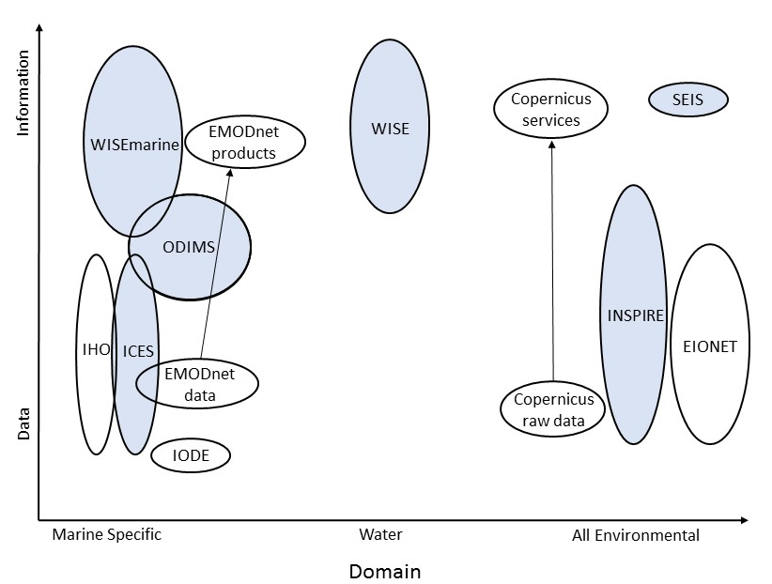

Acronyms
CMEMS | Copernicus Marine Environmental Monitoring Service
EIONET | European Environment Information and Observation Network
EMODnet | European Marine Observation and Data Network
ICES | International Council for the Exploration of the Sea
IHO | International Hydrographic Organisation
INSPIRE | Infrastructure for Spatial information in Europe
IOC | Intergovernmental Oceanographic Commission
ODIMS | OSPAR's Data and Information Management System
OSPAR | Convention for the Protection of the Marine Environment of the North-East Atlantic (The OSlo PARis Convention)
SEIS | Shared Environmental Information Service
WISE and WISEmarine | Water Information System for Europe

Other Successes
This year the Department for Business, Energy and Industrial Strategy (BEIS) introduced MEDIN to an exciting opportunity to partner with the Organisation for Economic Cooperation and Development (OECD) and the Global Ocean Observing System (GOOS) on a project “Valuing marine data”. We developed a joint OECD/MEDIN/GOOS questionnaire looking to fill gaps in our knowledge of the marine data value chain. The project uses MEDIN as a pilot for an anticipated wider international study and is an excellent way to promote MEDIN as providing global services. The Department for Environment, Food and Rural Affairs (Defra) have agreed to fund MEDIN’s involvement with this collaborative project in 2020-21.

Challenges and opportunities
Data Archive Centres apply quality-control flags to highlight data points that have potential quality issues. This year the flow of UK water column oceanography data to ICES has temporarily stopped, due to a mismatch in quality control flags between the national and international data centres. The British Oceanographic Data Centre (BODC) are working alongside ICES to identify a solution for the backlog of historic data.

The United Nations Sustainable Development Goals include a target to minimise and address the impacts of ocean acidification. MEDIN notes that there is not currently a systematic flow of data from its accredited oceanographic Data Archive Centre (BODC) to the Global Ocean Acidification Observing Network (GOA-ON), an international collaborative network. Some UK organisations have bypassed this issue by submitting ocean acidification data directly to GOA-ON. This short-term solution, which bypasses our national data centre, risks long-term access and security of data, as well as omitting the quality assurance provided by our DACs.

Our users require access to a broad range of marine data services and products in addition to access to raw data that forms the core of MEDIN’s activities. We work closely with UK marine data holders to encourage and help them deliver on their data sharing and publishing objectives. This includes the role of the Data Archive Centres in delivering data products and services.

We explore data management from new technology
This year we commissioned two small projects that aim to address data management issues associated with new and emerging marine technologies. We launched a call for proposals towards the end of 2019-20 and the successful projects will deliver during 2020-21. The first, led by DASSH, addresses archiving, discovering and accessing image and video data within the MEDIN framework. The MEDIN Automated Image Management System will be a proof of concept, hosted on behalf of the UK marine community by DASSH. The second, led by the British Oceanographic Data Centre (BODC), will provide easy, online access to discrete water sample data using a data server called ERDDAP. Water sample data is currently not well exposed through BODC’s online systems. ERDDAP has the potential to make it easy for users to access selected water sample data, release a lot of previously inaccessible data and improve the ‘2 clicks to data’ initiative.

ResourceSpace

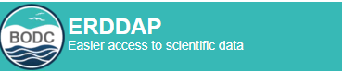

Challenges
This year, the uncertain funding situation had a big impact on our work in developing new resources and applications for our partners. Mitigation steps meant that other development work took priority, such as the redevelopment of our metadata editor. In particular, beyond an initial working group meeting involving Marine Management Organisation, Natural Resources Wales, ABPmer and OceanWise, we were unable to make further progress in developing a comprehensive list of reference layers. This work has been postponed to 2020-21. Access to reference layers is a key component of our plans to redevelop the MEDIN portal in 2020-21.

The UK marine community is a large and varied group of organisations spanning government departments and agencies, academia, commercial and industrial partners, and non-governmental organisations to name a few. It is only by working together that we can realise the full financial, scientific and environmental benefits of sharing our marine data. Communication with these varied stakeholders is key to developing a network that serves all our partners. We raise awareness of MEDIN and spread knowledge of our work throughout the network with high levels of outreach with the marine community and general public. This leads to greater awareness of the importance of marine data management and encourages the improvement of marine data management around the UK and internationally. Our main routes to reach our stakeholders are via our website and social media platforms; our free online newsletter, Marine Data News; and through outreach events, conferences and trade fairs. This year, we further enhanced our outreach and exposure by publishing a MEDIN marine data animation on the new MEDIN YouTube channel.

We share marine data knowledge
This financial year we published 3 issues of Marine Data News, our free online newsletter, featuring 11 articles from MEDIN sponsors and 7 articles from other MEDIN partners. Successfully delivered to 500 people, statistics reveal that the majority of our readers are based in the UK and USA. Our most popular articles this year covered monitoring of the Skomer Marine Conservation Zone (article by Natural Resources Wales in April 2019), a new interactive mapper for Marine Protected Areas (article by Joint Nature Conservation Committee in September 2019) and the cost benefit analysis of MEDIN (article by MEDIN in January 2020).

We engage with our community
A really effective way for us to engage with our users, both existing and prospective, is at conferences, trade fairs and outreach events. This year, MEDIN and its Data Archive Centres participated in over 40 national and international conferences and trade fairs, by giving presentations, providing a trade stand and sponsoring events.
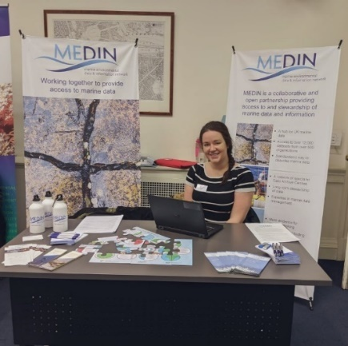 | 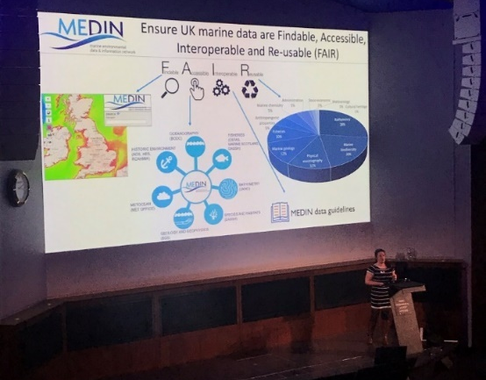

One of the highlights this year was when MEDIN participated in the Marine Alliance for Science and Technology for Scotland (MASTS) Annual Science Meeting in October 2019. We had a trade stand at the conference, providing a focus for us to talk directly to our users about their data management needs. At MASTS we gave a presentation to over 200 people on the importance of using MEDIN standards to create Findable, Accessible, Interoperable and Re-usable (FAIR) data. We sponsored Coastal Futures this year, a major national conference that attracts over 500 delegates from across the coastal marine community. In addition to engaging with participants on our trade stand, we presented a snappy three-minute overview of MEDIN.
Outreach to the general public is a newer activity for MEDIN but is one that allows us to engage with young people, who go on to be the scientists of the future. This year, MEDIN participated in the National Oceanography Centre (NOC) Open Day in June 2019, showcasing our new metadata poster and jigsaws to entertain visiting families. NOC welcomed thousands of people through the doors, which gave MEDIN good exposure and was a great outreach experience for the MEDIN core team.

We reach new audiences
MEDIN uses online platforms to reach out to new audiences. Our social media outreach has continued to grow substantially since April 2019. We post to LinkedIn and Twitter weekly, updating our followers on our work and sharing marine data information from our partners and sponsors. We increased our Twitter followers by 17% during 2019-20, reaching a total of 1503 followers at the end of March 2020. The total number of tweet impressions across 12 months is 195,546 (meaning the number of times tweets and posts have been seen across social media). Our average 15 tweets per month attracted on average 351 MEDIN profile visits each month.
A social media campaign was launched to advertise the Cost-Benefit Analysis survey carried out by eftec and ABPmer. Further details of the Cost Benefit Analysis of MEDIN can be found in the next section. We also collaborated with eftec at the Coastal Futures conference, showcasing the results of the Cost-Benefit Analysis report on the MEDIN stand.
The most popular tweet this year was advertising the MEDIN workshop in Plymouth. With 5856 impressions and 33 link clicks, it reached the most Twitter users.
In July, MEDIN registered an account with LinkedIn and set up an organisation page, which by March 2020 had 58 connections and 22 followers. LinkedIn is expanding MEDIN communications further into the academic and commercial fields.
 | 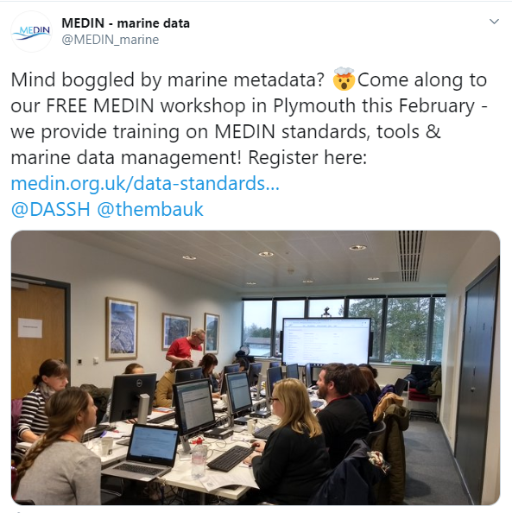
Figure 7: The number of followers of @MEDIN_marine on Twitter from April 2019-March 2020 | Figure 8: Our most popular tweet this year was an advert for one of our free training workshops.

The seas and coasts surrounding the UK have a complex range of stakeholders who manage, monitor, explore, conserve and sustainably exploit the marine environment. We seek to provide tools and services that support all UK users of marine environmental data. This requires significant coordination to address the (sometimes conflicting) requirements of our users. This work stream provides our partners with overarching coordination, alignment and oversight of marine data management activities in the UK. Long-term strategic planning, annual operational planning and reporting, project and financial management, essential for the success of MEDIN as a collaborative endeavour, are also covered by this work stream.

We provide value for money
Quantifying the benefits of managing marine data effectively has historically been considered difficult to do and in previous annual reports we have provided qualitative and anecdotal evidence of the benefits we bring our users. This year, for the first time, we commissioned analysis to quantify the costs and benefits of MEDIN’s services. The study concluded the benefits of our tools and services far outweigh the cost of providing them (benefit: cost ratio > 8). Our users recorded the largest financial benefits from time savings when they use our services to improve data management practices within their own organisations. Finding existing marine data using our portal and Data Archive Centres also saves our users significant time and money, as does avoiding collecting data if suitable data already exist. Other benefits around improving decision making were acknowledged by our users but proved difficult to monetise in the analysis.

We support national reporting
To support UK national and international marine reporting responsibilities such as for the UK Marine Strategy, the Marine Strategy Framework Directive, OSPAR and to the European Environment Agency, we provide marine data management advice and support to the key groups involved in marine assessments. In particular, during 2019-20 we supported the Marine Assessment and Reporting Group (MARG) and the four evidence groups that MARG coordinates to deliver on the UK Marine Strategy and the OSPAR Quality Status Report. These are: the Clean and Safe Seas Evidence Group (CSSEG); the Healthy and Biologically Diverse Seas Evidence Group (HBDSEG); the Productive Seas Evidence Group (PSEG); the Ocean Processes Evidence Group (OPEG).
This year we continued to highlight the importance of providing transparent and easy access to raw data used in national and international assessments, promoting the use of data citation through Digital Object Identifiers (DOIs) to do so. By highlighting omissions in raw data referenced in the assessments of Good Environmental Status under the UK Marine Strategy, we exposed data types that need additional support to ensure data are easy to find and access for future assessments. Biodiversity data used in assessments of our seas remain difficult to access. To help address this, MEDIN recommended establishing the BIOdiversity Data and Information Group (BIODIG) as a subgroup of the Healthy and Biologically Diverse Seas Evidence Group (HBDSEG). BIODIG is chaired by the MEDIN Data Archive Centre for species and habitats.

We expand our network
We successfully renewed all 14 existing funding agreements following the development of our ambitious new business plan (2019-24) and welcomed an additional sponsor, the Welsh Government, to the consortium of funders. Six of our sponsors have committed to five years of funding, which provides financial stability, allowing longer-term planning and decreasing the administrative burden. Five of our sponsors were only able to agree funding agreements for a year but we anticipate these will all be renewed in 2020, with the exception of Cefas. Cefas intend to continue to provide in-kind support to MEDIN through their active participation in MEDIN Working Group activities and the MEDIN Fisheries Data Archive Centre collaboration.
Our partners are organisations that commit to best practice marine data management and contribute in kind to delivering our vision. This year we welcomed SeaSearch as a new partner, taking the total number of partners to fifty-nine. Contact enquiries@medin.org.uk if you are interested in sponsoring or partnering MEDIN.

Challenges and opportunities
This year, in response to a call for evidence from the Geospatial Commission (GC), we pushed for marine specific issues to be forefront in the development of a national geospatial data strategy. The UK Hydrographic Office and British Geological Survey, both MEDIN Data Archive Centres and partner bodies of the Geospatial Commission, are working with MEDIN to ensure that the GC recognise MEDIN as providing the UK’s marine geospatial data infrastructure. Further progress is required with this.
An additional challenge arose this year when the National Oceanography Centre, the organisation that administers the management and operation of MEDIN, became a self-governing organisation, independent of the Natural Environment Research Council (NERC) and UK Research and Innovation (UKRI). These challenges were primarily administrative in nature but took time to resolve. NOC remains fully committed to hosting MEDIN.

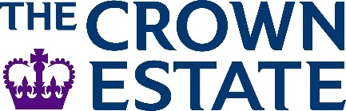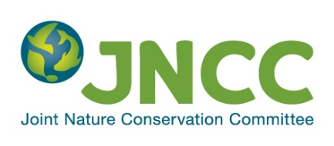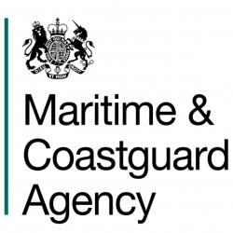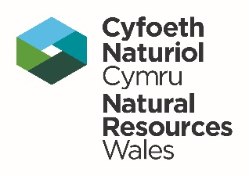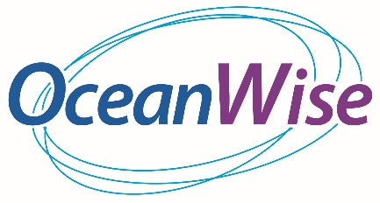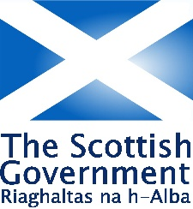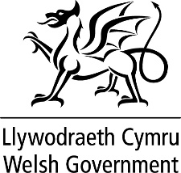

We were unable to capture the number of users of the Data Archive Centres.
At the point of writing, it remains unclear how the UK will interact with these European initiatives following the UK’s transition having left the EU.
Reference layers are key datasets that underpin many marine and coastal activities.
MEDIN Cost Benefit Analysis Final Report, November 2019 https://www.medin.org.uk/medin/sites/medin/files/documents/MEDIN%20Cost%20Benefit%20Analysis_Final%20Report.pdf

