MEDIN Data Archive Centre (DAC) Working Group Meeting 13

13:30-16:00 Wednesday 24th November 2020, Zoom meeting

Attending
Dan Lear – Chair (DL) | The Archive for Marine Species and Habitat Data (DASSH) | Paul Marks (PM) | United Kingdom Hydrographic Office (UKHO)
Caitlin Allan (CA) | Centre for Environment, Fisheries and Aquaculture Science (Cefas) | Peter McKeague (PMcK) | Historic Environment Scotland (HES)
James Ayliffe (JA) | British Oceanographic Data Centre (BODC) | Mary Mowat (MM) | British Geological Survey (BGS)
Emily Bashford (EB) | United Kingdom Hydrographic Office (UKHO) | Chris Perring (CPR) | United Kingdom Hydrographic Office (UKHO)
Chelsea Bradbury (CB) | The Crown Estate (TCE) | Clare Postlethwaite (CP) | Marine Environmental Data and Information Network (MEDIN)
Gareth Edwards (GE) | Royal Commission on the Ancient and Historic Monuments of Wales (RCAHMW) | Andy Richardson (AR) | United Kingdom Hydrographic Office (UKHO)
Tim Evans (TE) | Archaeloogy Data Service (ADS) | Callum Stone (CS) | Met Office
Summer Grundy (SG) | The Archive for Marine Species and Habitat Data (DASSH) | Oliver Williams (OW) | Centre for Environment, Fisheries and Aquaculture Science (Cefas)
Becky Irvine (BI) | The Archive for Marine Species and Habitat Data (DASSH) | Robin McCandliss (RM) | Marine Environmental Data and Information Network (MEDIN)
Apologies
Jens Rasmussen (JR) | Marine Science Scotland (MSS) | Helen Wojcik (HW) | United Kingdom Hydrographic Office (UKHO)
Gaynor Evans (GE) | Marine Environmental Data and Information Network (MEDIN)

1. Round table introductions
The MEDIN DAC Working Group (WG) formally thanked Jon Parr for many years of dedicated involvement in MEDIN and its previous incarnations. Dan Lear was welcomed as the new DAC WG Chair. The group introduced themselves for the benefit of new members (Paul Marks, Summer Grundy and Becky Irvine).

2. Review actions last meeting
Minutes from previous meeting (11th June 2020) were accepted without amendment.

Table 1: Actions from DAC WG meeting on 11th June 2020
Action |  | Progress
12.1 | DL to provide CMH some text for MEDIN website to state that DASSH remit includes seabird data. | Done
12.2 | CP/RM to provide DACs with portal database search strings for DAC metrics. | Done
12.3 | CP to include statement on MEDIN website and social media to say that MEDIN is continue to operate as normal during Covid-19. | Done – confined to social media and newsletter
12.4 | RM to complete report from provenance tracking questionnaire. | Ongoing
12.5 | DACs to provide information on what might be able to so about moving towards using controlled vocabularies in MEDIN metadata for all relevant fields in the MEDIN discovery metadata standard and use of PIDs for data submissions. | On agenda - closed
12.6 | DACs to include in annual reporting what services they provide that are OGC compliant and to ensure that the services are described using service metadata in the MEDIN Portal. | On agenda - closed
12.7 | CP to invite Alexandra Kokkinaki to next DAC WG meeting to discuss OGC API work. | Done
12.8 | CP to speak to other groups about horizon scanning and provide a proforma to collate information for presentation at MEDIN mega meeting. | On agenda - closed
12.9 | JR to lead an item on horizon scanning for new technology at the next MEDIN Mega meeting. | On agenda - closed
12.10 | DACs to let CP know if they require MEDIN financial help to cover their CoreTrustSeal application fee. | On agenda - closed
12.11 | RM to ask MEDIN Communications to update BGS and ADS DAC pages to include Core Trust Seal logo. | Ongoing – awaiting permission from CTS
12.12 | DL and helpdesk to develop initial plan to formalise multidisciplinary archive, e.g. ask DACs what they can accept at no cost; ask DACs to provide indicative costs for archiving data; collate and feedback at next DAC WG meeting. | On agenda - closed
12.13 | HW to send CP some narrative to explain the issue around UKHO records and why 2-clicks can’t be progressed. | Covered in update during meeting - closed
12.14 | CP to pull out proportion of records offering 2-clicks to data if UKHO is excluded. | In annual report - closed
12.15 | GE to provide DACs with a report of metadata validation changes over time. | Done
12.16 | CP to report on when the most recent version of Maestro will be released. | Expected at end of financial year. Closed
12.17 | CP to feed back when increased portal compliance checks will be implemented. | Validation checks will be switched on end June 2021, 3 months after release of Maestro. Closed.

3. DAC network status
3(a) Update from DACs
DACs each presented a brief summary of progress; please see accompanying slides in Appendix 1. Some key points included:
- ADS has become a member of the World Data System. A new online reporting system (OASIS) is being rolled out, with a focus on maritime. ADS is involved in a project proposal (“Unpath”) submitted to the Arts and Humanities Research Council (AHRC), in collaboration with HES, RCAMHW and MEDIN.
- RCAMHW is moving away from the data platform shared with HES and is developing its own. Recruitment of maritime staff is taking place in December, having been delayed due to Covid-19.
- The Met Office has implemented new hardware and software for automatic observations, though poor weather and Covid-19 travel limitations have disrupted deployment.
- BGS is involved in the Geospatial Commission Coastal Zone Mapping project. There is a new BGS website and marine data webpages.
- BODC has been undertaking mainly business as usual activity. BODC has completed a MEDIN small project to use ERDDAP technology to make discrete samples data available online.
- Cefas is making improvements to its DataHub and is planning to update metadata to MEDIN 3.1. A major upgrade of the Fisheries Survey System (FSS) is taking place to allow better integration with ICES.
- DASSH has made improvements to its QA processes. The DASSH CoreTrustSeal application is progressing well and submission is expected before the end of the FY.
- HES submitted its CoreTrustSeal accreditation application in September 2020 and is currently awaiting the outcome. HES is involved in a proposal submission under the Towards a National Collection (TANC) initiative to the AHRC, with RCAHMW and MEDIN.
- UKHO has permission from an additional 17 ports to share data, helping to fill in some gaps in UK data coverage. UKHO is working to migrate to the MEDIN 3.1 standard and is looking to reinvigorate making progress on 2-clicks to data.
- TCE is rebuilding the Marine Data Exchange (MDE) system to improve the public facing website for technical and non-technical audiences and to make it easier for users to upload and download data.
3(b) OneBenthic
CB gave an outline of the OneBenthic initiative, which was set up by the aggregates community. Recognising that benthic monitoring surveys were being carried out in isolation, they set up a regional seabed mapping programme to provide a baseline of UK seabed macrofauna, improve sustainability of dredging and reduce compliance monitoring costs. The initiative has grown and TCE has become actively involved. TCE is looking to ensure alignment with MEDIN. There is work underway with Cefas to develop apps for the offshore wind sector and get them using OneBenthic. DASSH and Cefas are both interested in further discussion.
Action 13.1: CB to arrange a meeting with interested MEDIN DACs (DASSH, Cefas) to discuss the OneBenthic initiative.

4. DAC Work Plan 2020-21
4(a) DAC Work Plan discussion
- New Development tasks
Provenance tracking: The DACs were reminded of the work presented at the last DAC meeting in June, with preliminary findings from the provenance-tracking questionnaire that was sent to the DACs in April 2020 (Paper P4). The DACs are being asked what they can do towards implementing the controlled vocabularies specified in the MEDIN Standard.
Action 13.2: RM to provide a template for DACs to capture narrative around issues with DAC adoption of controlled vocabularies in provenance metadata fields and how DACs might address them.
OGC compliant view and download services: MEDIN is asking the DACs to document their OGC compliant services as part of the annual reporting cycle for 2020-21. There was a brief discussion about what is useful to report. HES already report this as part of their annual metrics.
Action 13.3: Peter McKeague to share HES OGC compliance metrics with CP and RM as an example of what could be reported.
The group felt that it would be useful to report the current state of OGC compliance, with URLs, and a narrative section to describe the service and capture future plans.
Action 13.4: RM to update DAC annual report template to include a section for DACs to report on OGC compliant services (with URLs) and provide narrative to describe the service and capture future plans.
Defining an API structure for DACs to adopt: Alexandra Kokkinaki presented an update on Open Geospatial Consortium (OGC) work on the Environmental Data Retrieval (EDR) API. See Appendix 2 for slides. The MEDIN Workplan includes an activity for development of a cross-DAC API for data retrieval and MEDIN wishes to ensure alignment with agreed international standards such as those developed by OGC. One of the benefits of using an API is that it would allow easier interaction/data retrieval across DACs and with data providers around the globe in a standard way. The DACs were impressed at how well evolved the OGC EDR API is and are keen to explore this as a standard for the cross-MEDIN DAC API.
This will also be discussed at the MEDIN joint Working Group meeting on Thursday 26th November 2020. It would be sensible to set up a subgroup to take this activity forward. CP advised that the MEDIN Sponsors have identified this activity as a top priority and there will be some MEDIN funding available to assist a couple of DACs in piloting the development of an API.
Horizon scanning for new technologies: CP has developed a proforma to capture technology challenges/opportunities facing MEDIN DACs. This will also be introduced at the joint Working Group on 26th Nov. The intention is to capture challenges with existing technology as well as identifying new technologies on the horizon and have a full discussion on this at the 2021 joint Working Group meeting.
Strengthen and formalise triage process for archive of multidisciplinary data
The MEDIN Helpdesk has developed a questionnaire for DACs to complete which will document the steps in the archive process at the different DACs and help identify gaps in the current workflow for archive of multidisciplinary data. The responses will be collated and a summary report will be brought to the next DAC WG meeting.
Action 13.5: Summer Grundy to report on DAC questionnaire and plan for strengthening the triage process for multidisciplinary data at DAC WG meeting in Q1 2021.
4(b) MEDIN small funded projects
BODC has completed the small project to expose samples data using ERDDAP. The work was carried out in two sprints and focused on the Liverpool Bay Coastal Observatory samples dataset. The first sprint involved investigation of how to structure the data for exposure and also updating of the ERDDAP servers. The second sprint generated the ERDDAP compatible data and metadata views, updated the MEDIN metadata record to allow access via one click of the URL to enable download of the entire data set and also access to the ERDDAP instance of the data set, enabling users to select subsets of the data and make graphs or download the data in a variety of formats.
DASSH was funded to develop a MEDIN Automated Image Management System (MAIMS). This system allows users to submit images and browse images held in the system along with the MEDIN metadata. The project is now ready for external testing and DASSH are working with JNCC, Nature.Scot and the Sea Mammal Research Unit to test capacity. The project will also be demonstrated at an upcoming meeting of the Healthy and Biologically Diverse Seas Evidence Group (HBDSEG) Biodiversity Data and Information Group (BioDIG). The anticipated completion date is March 2021.
4(c) DAC accreditation: adopting CoreTrustSeal
CP gave an update on her investigations of using the CoreTrustSeal (CTS) umbrella process for DAC accreditation. Some DACs were in favour of taking the umbrella approach, other DACs less so, mainly for DACs that have already achieved the CTS accreditation, due to fears that it might interfere with their reaccreditation cycle. CP will give one last push to see if all the DACs can agree to apply under an umbrella and, if not, will take the decision to drop it.
CoreTrustSeal has confirmed that it is fine to accredit a component of an organisation, as long as it is clear what element is being accredited.
Update from DACs:
- HES has submitted its application (September 2020) and is awaiting the outcome.
- ADS and BGS, as accredited DACs, are reviewers for CoreTrustSeal.
- DASSH is using the FAIRsFAIR initiative to help with its application and is planning to submit by March 2021.
- Met Office is hoping to apply for accreditation for subset of its data systems, targeting its marine database.
- UKHO are making good progress with their application and aiming to submit in January 2021, focusing on the bathymetry DAC.

5. Promoting the DAC Network
5(a) OECD – Valuing marine data
The Organisation for Economic Cooperation and Development (OECD) is working with the Global Ocean Observing System (GOOS) on a project fill in gaps in our understanding of the value chains of marine observations. A survey was carried out and the results are currently being analysed by OECD. A first draft of the reported results is expected by the end of Dec 2020, which the DACs will be invited to review.
5(b) Forthcoming international meetings
This was covered in the DAC slides and is summarised below.
- EMODnet Biology Data Products Workshop: 15th -19th June
- EMODnet Biology Transatlantic Data Products Workshop: 9th October
- EMODnet Geology and EMODnet Ingestion meetings
- International data sharing workshop for non-UN IGOs, Global and Regional organisations and projects, NGOs and private sector: 12th October
- Healthy and Biologically Diverse Seas Evidence Group (HBDSEG): 14th October
- OBIS Steering Group: 17th -20th November
- FAIRs FAIR Certification Workshop: 19th November
- ICES Data and Information Group (DIG)

6. Coordinated data archiving
6(a) Strengthen and formalise the archiving of multidisciplinary data
This item was discussed under item 4(ii).

7. DAC Data Access Services
7(a) QC of existing metadata records

Gaynor Evans provided a report showing the status of metadata validation errors for the DACs. DACs are asked to check the report and investigate reasons for unexpected errors in compliance. As discussed earlier in the meeting, the plan is to switch on additional checks in June 2021 following the release of the new Maestro version.

Action 13.6: DACs to check latest metadata compliance report and investigate unexpected errors.

8. Working Group engagement
DL reminded the DACs that if there are any areas of the MEDIN WorkPlan that DACs are interested in leading, it would be welcome.
Feedback indicates that it would be helpful to standardise the reporting of minutes and actions across the MEDIN Working groups. The DACs agreed that this would be useful.
Action 13.7: RM to arrange for MEDIN DAC SharePoint area to share MEDIN DAC documents and actions using same naming conventions as other MEDIN Working groups.
Action 13.8: RM to produce spreadsheet for tracking DAC WG actions, giving access to DACs to view and edit.

9. AOB
Next meeting – planned for Q1 of 2021. RM to poll for dates.

Table 2: Actions from DAC WG meeting on 24th November 2020
Action |  | Progress
13.1 | Chelsea Bradbury to arrange a meeting with interested MEDIN DACs (DASSH, Cefas) to discuss the OneBenthic initiative.
13.2 | Robin McCandliss to provide a template for DACs to capture narrative around issues with DAC adoption of controlled vocabularies in provenance metadata fields and how DACs might address them.
13.3 | Peter McKeague to share HES OGC compliance metrics with CP and RM as an example of what could be reported.
13.4 | Robin McCandliss to update DAC annual report template to include a section for DACs to report on OGC compliant services (with URLs) and provide narrative to describe the service and capture future plans.
13.5 | Summer Grundy to report on DAC questionnaire and plan for strengthening the triage process for multidisciplinary data at DAC WG meeting in Q1 2021.
13.6 | DACs to check latest metadata compliance report and investigate unexpected errors.
13.7 | Robin McCandliss to arrange for MEDIN DAC SharePoint area to share MEDIN DAC documents and actions using same naming conventions as other MEDIN Working groups.
13.8 | Robin McCandliss to produce spreadsheet for tracking DAC WG actions, giving access to DACs to view and edit.
12.11 | RM to ask MEDIN Communications to update BGS and ADS DAC pages to include Core Trust Seal logo. | Ongoing – awaiting permission from CTS

Appendix 1: DAC summary slides
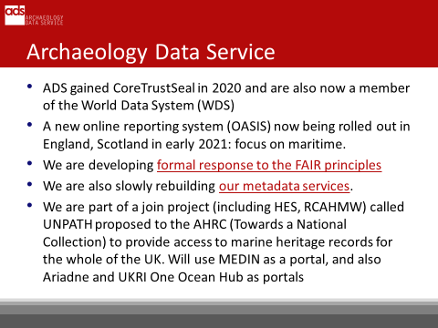

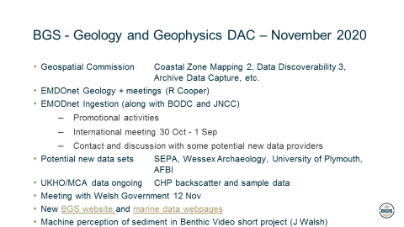

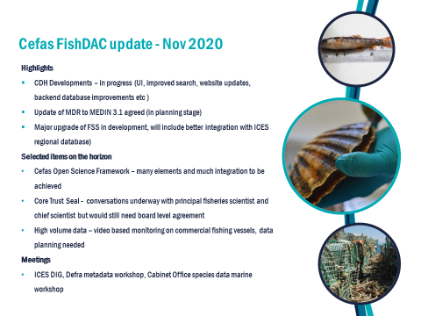

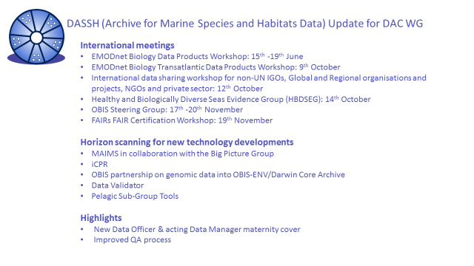

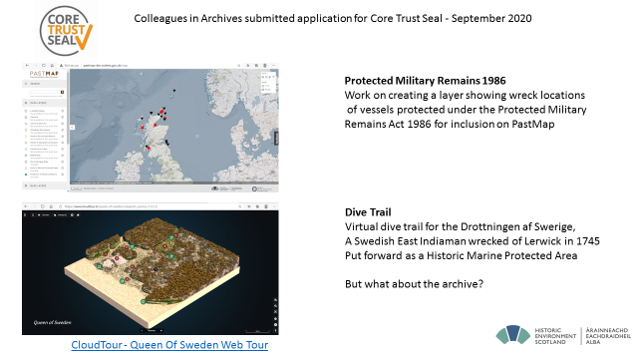

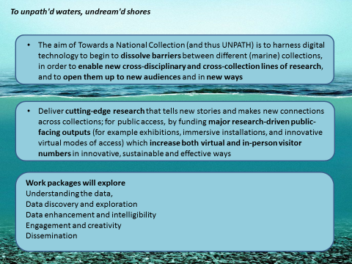

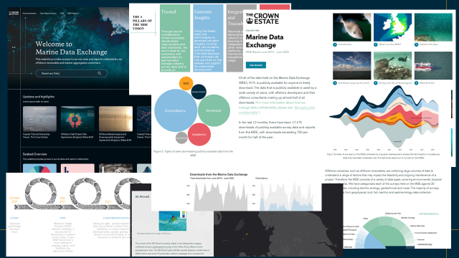
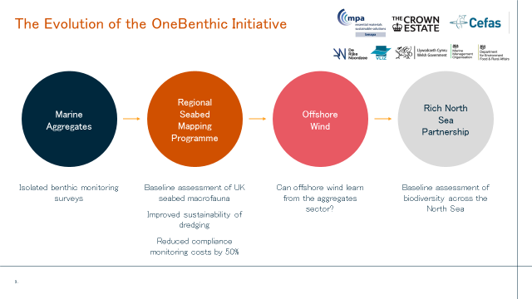
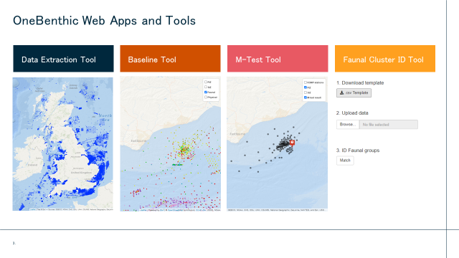
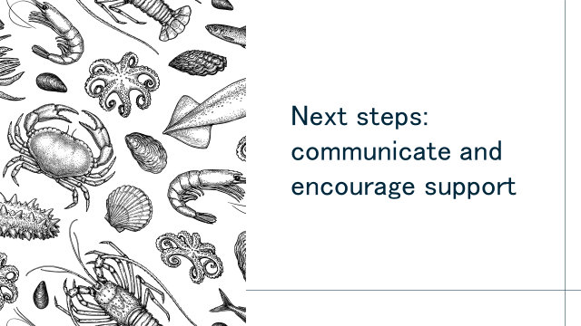

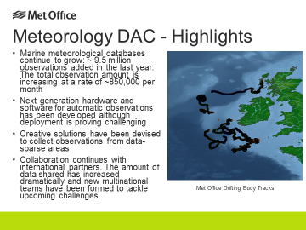
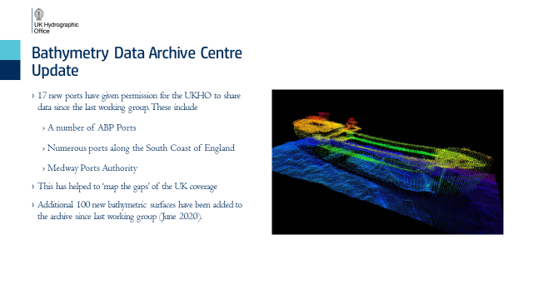
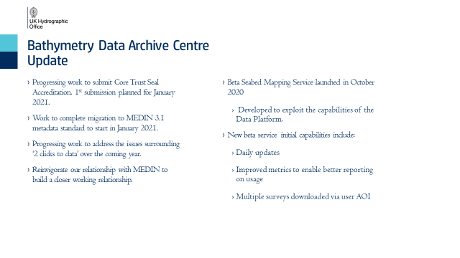

Appendix 2: Environmental Data Retrieval API
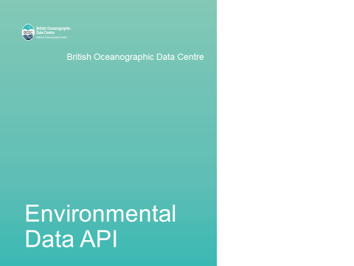
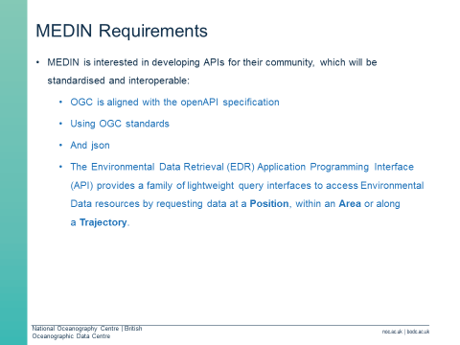
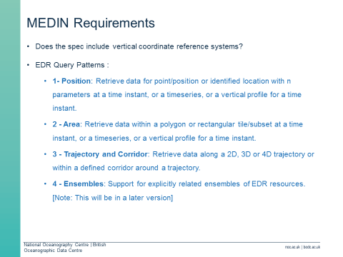
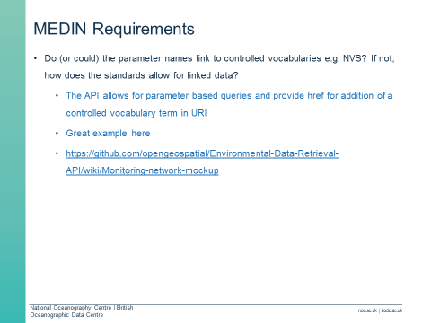
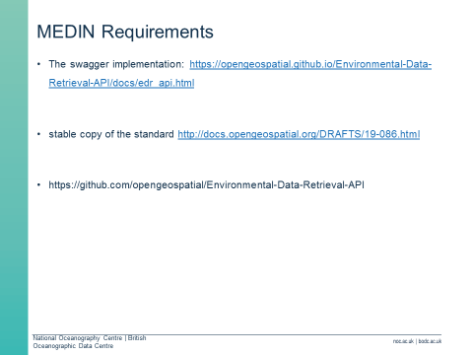
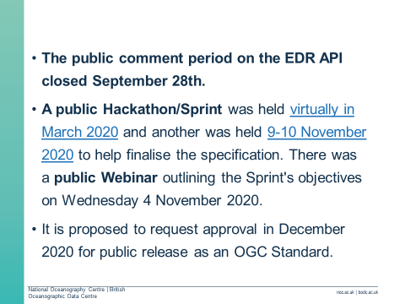
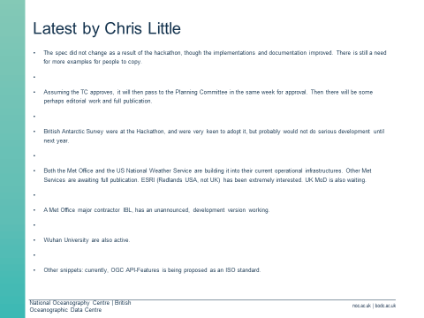

Appendix 3: MEDIN Small Projects
BODC
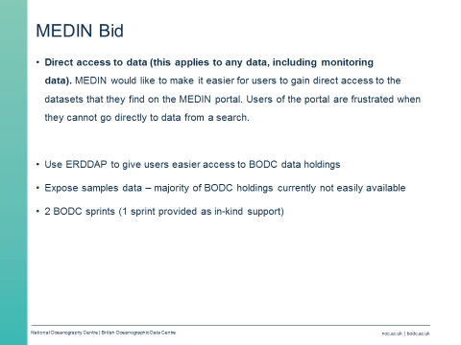
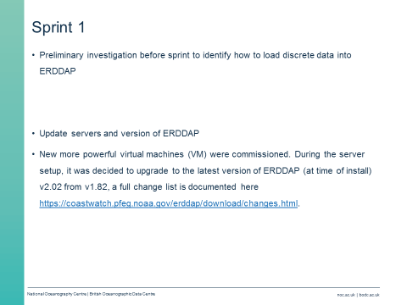
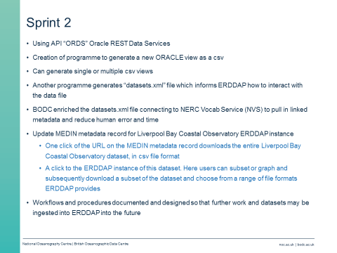
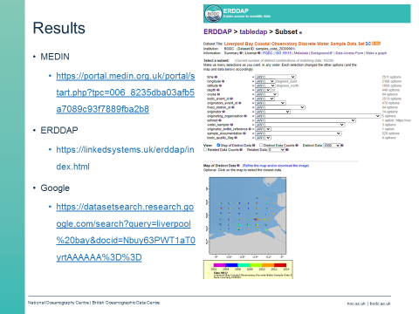

DASSH:
