MEDIN Provenance tracking – Part 2
One of the tasks in the new MEDIN Business Plan (2019-24) is to develop a DAC-wide approach to provenance tracking, with a particular focus on better capture of originator information.

A questionnaire was circulated based on elements relating to provenance present in the MEDIN Discovery Metadata Standard. The questionnaire was designed to capture how the DACs populate these fields and was sent to the DACs in April 2020.

A follow up questionnaire was sent out in January 2021 focusing on the provenance-related metadata fields where MEDIN specifies a controlled vocabulary. The aim was to better capture what the issues are and what might be done to enable the DACs to adopt MEDIN-recommended controlled vocabularies when populating provenance metadata. Note that there are only 9 out of the 10 MEDIN DACs represented here, as RCAHMW does not currently publish metadata records in the MEDIN catalogue.

Results
- Organisation name
Three DACs use the MEDIN-recommended controlled vocabulary EDMO for Organisation Name. Cefas is carrying out work to enable use of EDMO in its metadata records. For other organisations, the main barriers to using EDMO include:
- Requires development work
- Requires internal vocabulary mappings to EDMO
- Requires organisations to be added to EDMO
- Lack of resources and not a high priority for DACs

Further detail on the responses from the individual DACs regarding use of EDMO are given in the table below.
DAC | Issue using EDMO | Potential solution
MSS | Marine Scotland’s metadata catalogue needs to be used to enter authors/submitters and organisations that are not necessarily on EDMO. Thus we have not implemented an EDMO ID tracking. | Developer time to modify our catalogue to incorporate EDMO content and then determine and implement business rules for:  1) Only submit metadata that contains at least one EDMO entry, and only submit EDMO entries to MEDIN (other records will not be exportable)  2) Write importers to routinely take in the EDMO csv file to update list & add new organisations. Develop checks for duplicate entries (e.g. organisation has been added on MS catalogue, and is now also available on EDMO)  This resource is currently not available in Marine Scotland.
BGS | Requires resource to look into this and cross-check vocabularies. DAC resources are limited. | Requires more time and resources.
Cefas | Legacy issue, working to resolve this to meeting standard. | Developments of the MDR system, which are in progress in test environment.
HES | No controlled vocabulary in place for Organisation name, but every Organisation in Oracle database has a unique identifier | EDMO List not fully populated with archaeological organisations (e.g. Marine Archaeology Services - ORCA (orca-archaeology.org). Would not handle EDMO Organisation value in internal system.  Action - Production change request: Add related links table to internal ORGANISATION and PEOPLE tables  Action: review EDMO list for omissions and discuss how to add
ADS | We’ve historically used DC, and latterly DataCite terms to define creator, contributor etc so never see the need. | We would need to do a mapping from our terms to EDMO, so that it appears in the MEDIN metadata export.
UKHO | We believe we use our internal list of organisations.

- Responsible Party Role
Five DACs use the MEDIN-recommended controlled vocabulary for Responsible Party Role. Note that Cefas and DASSH are planning to adopt this going forward. ADS uses DataCite vocabularies and would need to carry out a mapping between vocabularies. HES uses free text currently and would need to create additional fields in its Oracle tables and discuss how to implement the ISO code list.
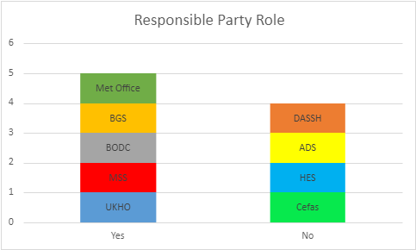

Further detail on the responses from the individual DACs regarding use of the MEDIN-recommended vocabulary for Responsible Party Role are given in the table below.
DAC | Issue using MEDIN Vocabulary for Responsible Party Role | Potential Solution
ADS | We’ve historically used DC, and latterly DataCite terms to define creator, contributor etc so never see the need. | We would need to do a mapping from our terms to the ISO list, so that it appears in the MEDIN metadata export.
HES | No controlled vocabulary in place for Responsible Party Role. | Would require examples of terminology used and how this is implemented to understand how it could be applied in our systems.  We do record ‘Role’ as a free text field against PEOPLE/ORGANISATION associated with a COLLECTION record and against the EVENT (activity) record.  Action: - Production change request: Add related links table to PEOPLE / ORGANISATION tables  Action: review ISO Responsible party code list for omissions and discuss how to add
Cefas | Unsure because the guidance states that ‘(Metadata Point of Contact–this is encoded as MD_Metadata/gmd:contact unlike all other Responsible Party roles which are encoded as gmd:pointofContact within identificationInfo):’  Difficulty understanding XMLs so unsure as to whether our outputs for Metadata Point of Contact are able to use the ISO codelist.  Also aware we are missing the '22.3 - Distributor' and '22.5 - Owner' sub elements completely form our outputs. | Developments of the MDR system, which are in progress in test environment.
DASSH | The current Metadata Editor does not include this vocabulary, but the new version will. | New version of Metadata Editor

- Limitations on Access:
Six DACs use the MEDIN-recommended controlled vocabulary for Limitations on Access.
The new version of the Metadata Editor at DASSH will include the recommended vocabulary. ADS also intends to use the MEDIN-recommended controlled vocabulary, once it has carried out minor development work. It is not as straightforward for HES to adopt use of this vocabulary.
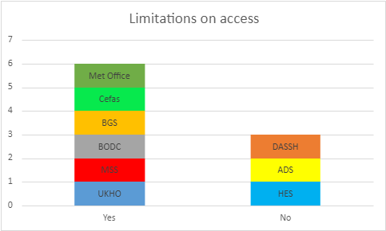

Further detail on the responses from the individual DACs on use of the MEDIN-recommended controlled vocabulary for Limitations on Access are given in the table below.
DAC | Issue using MEDIN-recommended vocabulary for Limitations on Access | Potential Solution
ADS | We’ve never had limitations on Access. All data is free to use subject to the specific licence agreement, so having this as a separate field in our metadata has never been required. | We’ve agreed internally to use the ISO codes going forward – this will entail an extension to the ADS CMS (back-end db) and adding in an appropriate drop down in the user interface so it is recorded for all ADS archives. This is a minor development task.
HES | ISAD(G) Element ‘Conditions of Access and Use’ are used. | Would require system change (Unlikely) – or map to ISO values on export.
DASSH | The current Metadata Editor does not include this vocabulary, but the new version will. | New version of Metadata Editor

Questions for the DACs:
- What does success look like for a DAC-wide approach to provenance tracking?
- Are there particular fields we should focus on to try and get all DACs using the MEDIN-recommended controlled vocabulary?
- Where does a DAC-wide approach to provenance tracking sit in terms of priority with other tasks on the DAC work plan?
- What are the next steps?

