MEDIN Joint Working Group Meeting  December 2021 | Paper P2
Discussion Paper | This document is the MEDIN Annual Report for 2020-21, which has now been approved by the MEDIN Sponsors’ Board.  The MEDIN Working Groups are thanked for their contributions towards MEDIN’s progress in 2020-21 and are asked to share the report with their colleagues.  In the meeting there will be an opportunity to share opinions and ask questions about the report. Suggestions on how to improve future reports are always welcome.

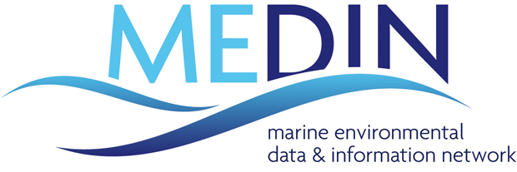Annual Report
2020-2021

‘measure once, use many times’

2020-21 was the second year of the Marine Environmental Data and Information Network’s (MEDIN) ambitious five-year (2019-24) Business Plan. MEDIN is strengthening and evolving as the leading authority on the management of marine environmental data, albeit with a reduced level of funding, down from £763K per year before 2011 to around £507K since 2019. This year was a turbulent one across the world with a global pandemic necessitating changes to working practices and travel. Nevertheless, we successfully delivered the bulk of our planned work, through the commitment and hard work of our core team, our Data Archive Centres, our sponsors and all our partners. Unsurprisingly, the main disruption we experienced was to work that, in previous years, involved face-to-face gatherings, such as running training workshops, holding meetings, and presenting at conferences or trade fairs. Most of these events were able to go ahead virtually, making use of a range of digital solutions to remote working. We will use the experiences of 2020-21 to enhance our ability to work efficiently with all our partners across the UK.
The 2019-24 MEDIN Business Plan was developed around 3 strategic goals, which encompass MEDIN’s vision for all UK marine data to be Findable, Accessible, Interoperable and Reusable (FAIR). MEDIN has defined seven Key Performance Indicators (KPIs) based on these strategic goals. 2019-20 provided the baseline for these KPIs, towards which we compare the KPIs for 2020-21. The KPIs are listed below.

Strategic Goal A: MEDIN delivers its vision for all of the UK marine community by providing tools and services beneficial across the wide spectrum of the marine data community and the full data lifecycle; ensuring widespread archiving and open access to high-quality data to enable maximum use and security and to provide integration and coordination of services.
We have 2 Key Performance Indicators which measure progress against this goal:
KPI 1: Number of active MEDIN partners,
KPI 2: Number of users of MEDIN tools and services.
How did we perform this year?
59 partner organisations |  | 2314 users
Strategic Goal B: MEDIN delivers the technical infrastructure required to ensure UK marine environmental data are Findable, Accessible, Interoperable and Reusable (FAIR) by providing: a coordinated network of marine Data Archive Centres; a single portal to access all UK marine data; and standards, tools and services to support the UK marine community.
We have 2 Key Performance Indicators which measure progress against this goal:
KPI 3: Summary of access to data described in the MEDIN portal,
KPI 4: Number of requests for data at MEDIN Data Archive Centres.
How did we perform this year?
64% data available from MEDIN portal is archive quality* | 1.6 million requests for data
Hatched bars show information for 2020 and solid bars show information for 2021. | Note the logarithmic scale on the y-axis. Hatched bars show information for 2020 and solid bars show information for 2021.

Strategic Goal C: MEDIN delivers an open and constructive data management culture: fostering global collaboration and partnerships; addressing skills gaps; providing training and education.
We have 3 Key Performance Indicators which measure progress against this goal:
KPI 5: Number of people receiving regular MEDIN updates,
KPI 6: Number of organisations receiving MEDIN data management training
KPI 7: Number of national and international conferences or trade fairs where MEDIN is represented.
How did we perform this year?
1,507 update recipients | New online training resources developed
Hatched bars show information for 2020 and solid bars show information for 2021.
36 events where MEDIN represented

Available funds
MEDIN is a collaborative initiative that attracts sponsorship from like-minded organisations that recognise the scientific, environmental and financial benefits of providing a coordinated, national framework for managing the UK’s valuable and unique marine data resources. £611,463 was available to fund MEDIN activities in 2020-21: £507,000 from the consortium of 15 sponsors, in addition to £89,863 carried over from previous years and £14,600 funding from Defra for a special project.

Sponsor Name | Funding level for 2020-21
DEFRA: Department of Environment Food and Rural Affairs | £175,000
NOC: National Oceanography Centre/NERC: Natural Environment Research Council | £131,000
Scottish Government | £82,000
BEIS: Department of Business, Energy and Industrial Strategy | £30,000
UK Hydrographic Office | £19,000
Met. Office | £14,000
Cyfoeth Naturiol Cymru / Natural Resources Wales | £14,000
The Crown Estate | £10,000
Maritime and Coastguard Agency | £7,000
OceanWise | £5,000
Joint Nature Conservation Committee | £5,000
DAERA: Department of Agriculture, Environment and Rural Affairs, Northern Ireland | £5,000
AFBI: Agri-Food and Biosciences Institute | £5,000
Welsh Government | £5,000
TOTAL available to MEDIN from sponsorship funding | £507,000
Carry over from previous years | £89,863
Funding from Defra for special project | £14,600
Final Total available for 2020-21 | £611,463

Expenditure
MEDIN is split into seven Work Streams (WS), each with its own budget and project manager, to allow efficient delivery and management of MEDIN’s programme of work. We spent £509,899 during 2020-21: £321,946 on the employment costs of the MEDIN project managers (the MEDIN Core Team) including all individual and organisational overheads, £155 on travel and subsistence costs and £175,038 on external contract costs required for the operation, maintenance and development of the MEDIN framework.

Expenditure category | Expenditure in 2020-21 | Work Stream | Expenditure in 2020-21
Employment Costs of Core Team | £321,946 | WS1: Data Archive Centres | £113,701
Travel and Subsistence | £155 | WS2: Standards | £95,998
External Contracts | £175,038 | WS3: Portal | £103,976
Subtotal | £497,139 | WS4: International Links | £13,702
Special project (funded by Defra) | £12,760 | WS5: Resources and Applications | £26,089
 |  | WS6: Communications | £49,300
 |  | WS7: Management and Coordination | £94,374
 |  | Special Project | £12,760
TOTAL expenditure | £509,899 | TOTAL expenditure | £509,899

End of year balance
Like most organisations around the world, this year saw uncertainty brought about by the global pandemic. The MEDIN Core Team moved to home working and continued to work effectively on progressing MEDIN’s planned work, so spending on staff costs proceeded as planned. MEDIN stopped all but essential travel throughout the year, following the guidance of the UK government. Subsequently spending on travel and external contracts was much lower than planned, due to MEDIN not hosting face-to-face meetings or attending external conferences. Overall this resulted in an end-of-year underspend of £71,601 for 2020-21 on top of a planned underspend of £29,963.

External expenditure
This year MEDIN spent £175,038 on external contract costs required for the operation, maintenance and development of the MEDIN framework.
Supplier | Item | Cost
BGS | DAC costs 2020-21 | £11,000
BODC | DAC costs 2020-21 | £11,000
MBA / DASSH | DAC costs 2020-21 | £13,200
UKHO | DAC costs 2020-21 | £13,200
Met Office | DAC costs 2020-21 | £13,200
Fish DAC CEFAS | DAC costs 2020-21 | £6,600
Fish DAC Marine Scotland | DAC costs 2020-21
Historic Environment DAC ADS | DAC costs 2020-21 | £6,000
Historic Environment DAC HES | DAC costs 2020-21 | £6,000
Historic Environment DAC RCHAMW | DAC costs 2020-21 | £6,000
 | Total WS 1 expenditure | £86,200
MBA / DASSH | Standards Working Group Support | £6,933
HR Wallingford | Metadata Maestro and MEDIN Schematron update | £13,200
DASSH | Upgrade to online tool
 | Total WS 2 expenditure | £20,133
MARIS | UKDMOS Portal Maintenance 01/05/20-01/05/21 | £1,500
BODC | MEDIN product hosting and support | £5,000
NOC | Website hosting and support | £5,000
MARIS | MEDIN portal and catalogue hosting and maintenance Jan 2020-Dec 2020 | £8,100
MBA / DASSH | MEDIN Helpdesk April 2020-March 2021 | £4,637
MARIS | Upgrade to MEDIN portal
 | Total WS 3 expenditure | £31,473
BODC | Small project: Direct access to discrete water sample data using ERDDAP | £10,800
MBA / DASSH | Small project: MEDIN Automated Image Management system | £7,500
 | Total WS5 expenditure | £18,300
3men squared limited | Graphic design support | £2,520
MASTS Annual Science Meeting | Conference fee | £120
CMS | Conference fee | £108
Dell | Laptop for Core Team member | £887
Multiple suppliers | Courier costs and software license | £132
 | Total WS6 expenditure | £3,768
OceanWise | Representing MEDIN at PSEG | £523
MBA / DASSH | Representing MEDIN at HBDSEG and BioDIG meetings | £6,763
Professor Peter S. Liss | Chairing MEDIN, representing MEDIN at MSCC | £6,720
Dell | Laptop for Core Team member | £979
Bob Earll CMS | Advertise a MEDIN/OECD/GOOS survey | £180
 | Total WS7 expenditure | £15,165

Governing Body
MEDIN was established in 2008 as a collaborative, cross-sectoral initiative for public good. Our governing body, the MEDIN Sponsors’ Board, comprises one member from each funding organisation, ensuring each funder has the opportunity to influence our national and international work. The Board is responsible for defining the strategic direction of MEDIN, approving work programmes and budgets. Professor Peter Liss CBE FRS chairs the MEDIN Sponsors’ Board, which met twice during 2020-21.
Sponsor Name | Sponsors’ Board member 2020-21
DEFRA: Department for Environment Food and Rural Affairs | Sofiya Stoyanova
NOC / NERC: National Oceanography Centre/ Natural Environment Research Council | Dr. Robin McCandliss
Scottish Government | Dr. Jens Rasmussen
BEIS: Department of Business, Energy and Industrial Strategy | Saravanan Marappan
UKHO: UK Hydrographic Office | James Carey
Cyfoeth Naturiol Cymru / Natural Resources Wales | Helen Wilkinson
Met. Office | Jon Turton
The Crown Estate | Chelsea Bradbury
Maritime and Coastguard Agency | Paula English
JNCC: Joint Nature Conservation Committee | Elly Hill
OceanWise | John Pepper
DAERA: Department of Agriculture, Environment and Rural Affairs, Northern Ireland | Colin Armstrong
AFBI: Agri-Food and Biosciences Institute | Dr. Matt Service
Welsh Government | Shelley Vince
Chair | Professor Peter Liss CBE FRS

Operational Groups
Our Board is supported by an Executive Team, which provides interim guidance and management of our operational work programme between Sponsors’ Board meetings. The Executive Team is made up of four sponsor members (DEFRA, NOC/NERC, Scottish Government and a fourth member, currently UKHO, as voted by the Sponsors’ Board), three subject experts (the chairs of the MEDIN Working Groups) and the MEDIN work stream managers. Our Executive team met four times in 2020-21.
Executive Team member | Sponsor/Expert member | Executive Team member | MEDIN work stream member
Sofiya Stoyanova (DEFRA) | Sponsor member since 2019 | Dr. Clare Postlethwaite | Since 2012
Dr. Robin McCandliss (NOC/NERC) | Sponsor member since 2020 | Dr. Robin McCandliss | Since 2017
Dr. Jens Rasmussen (Scottish Government) | Sponsor member since 2019 | Dr. Sean Gaffney | Since 2014
James Cooke (UKHO) | Sponsor member since 2017 | Dr. Gaynor Evans | Since 2008
Jon Parr (MBA) | Expert member 2008-2020 | Charlotte Miskin-Hymas | Since 2017
Dan Lear (MBA / DASSH) | Expert member since 2020 | Roseanna Wright | Since 2018
Graeme Duncan (JNCC) | Expert member since 2019
Dr. Mike Osborne (OceanWise) | Expert member since 2008
Professor Peter Liss CBE FRS | Chair since 2008

The seven MEDIN work streams are project managed and supported by the MEDIN Core Team - seven part-time staff employed by the National Oceanography Centre within the British Oceanographic Data Centre. In addition to project management, the MEDIN Core Team provide leadership for the work streams and secretariat as well as administrative support to MEDIN. The MEDIN Core Team met monthly in 2020-21.
Core Team member | Work Stream (WS) role
Dr. Robin McCandliss | Lead on DACs WS
Roseanna Wright | Lead on Standards WS
Dr. Sean Gaffney | Support to Standards WS
Dr. Gaynor Evans | Lead on Portal, Products and Services WS
Dr. Clare Postlethwaite | Lead on International; Resources and Applications; and Management and Coordination WS
Charlotte Miskin-Hymas | Lead on Communication WS and support to International WS
Paul McGarrigle | Administrative Support
Dr. Clare Postlethwaite | Coordinator since 2014

Working Groups
Our partners help deliver our strategic goals by participating in our working groups, which met regularly throughout 2020-21.
DAC Working Group | Standards Working Group | Portal Steering Group | Joint Working Group
ADS | BGS | DASSH | ABPmer
BGS | BODC | Marine Scotland | ADS
BODC | Cefas | NRW | BGS
Cefas) | DASSH | OceanWise | BODC
DASSH | JNCC | UKHO | Cefas
Historic Environment Scotland | NRW | Uni. of Edinburgh | DASSH
Marine Scotland | OceanWise |  | Historic Environment Scotland
Met Office | SAMS |  | JNCC
RCHAMW) | Nature Scot |  | Marine Scotland
The Crown Estate | The Crown Estate |  | DASSH
UKHO | UKHO |  | Met Office
 |  |  | NRW
 |  |  | NatureScot
 |  |  | OceanWise
 |  |  | RCAHMW
 |  |  | The Crown Estate
 |  |  | UKHO
 |  |  | Uni. of East Anglia
 |  |  | Uni. of Edinburgh
Jon Parr (Marine Biological Association)  Co-chair 2008-2020  Dan Lear (DASSH)  Co-chair since 2020  Dr. Robin McCandliss (MEDIN)  Co-chair since 2017 | Graeme Duncan (JNCC)  Co-chair since 2019  Roseanna Wright (MEDIN)  Co-chair since 2019 | Dr. Gaynor Evans (MEDIN)  Chair since 2008 | Dr. Clare Postlethwaite (MEDIN)  Chair since 2016

Parent Body
The Marine Science Coordination Committee (MSCC) is the parent body for MEDIN, providing strategic direction, which MEDIN uses to define its high-level goals. MEDIN reports to MSCC through this annual report and shorter progress updates as requested.

Administrative Body
The management and operation of MEDIN is administered by the National Oceanography Centre (NOC), on behalf of the MSCC.

The MEDIN Data Archive Centres (DACs) provide the cornerstone for long-term management of UK marine data and are pivotal for delivering MEDIN’s 'collect once, use many times' philosophy. The benefits of having a coordinated network of DACs and reusing data helps to avoid duplication of primary data gathering efforts, brings time savings through organisations not having to manage their own data (better formatting and storage), and contributes to the drive towards making data Findable, Accessible, Interoperable and Reusable (FAIR). Currently 65% of the data accessible from the MEDIN portal are considered “archive quality”. In other words, they are managed, quality controlled and disseminated by one of our accredited Data Archive Centres.

Our DACs provide
- Secure, long-term curation of key marine data sets, according to best practice and to relevant national and international standards.
- Clear, searchable information on their data holdings by the generation and publication of metadata on the MEDIN portal.
- Open and easy access to their data, wherever possible.
- The first point of call for expertise in the management of marine data.
The DACs cover a wide spectrum of data within the marine environment, including bathymetry; fish and shellfish, fisheries, aquaculture and related samples; the historic environment; marine geology and geophysics; marine species and habitats; marine meteorology; water column oceanography. The MEDIN DAC network provides users with a safe place to deposit and access data for the long term.

We provide direct access to UK marine data
We promote open and easy access to marine data. Our DACs continue to develop their systems and processes to make it as easy as possible to access the data they manage. This year we continued to improve direct access to data, whereby a user can access data from the MEDIN Portal within ‘2 clicks’. Three of our DACs provide direct access to over 80% of their data holdings, with two of those at 90% or over (Figure 1). In total, 40% of the data held in our DACs are available to download or use within ‘2 clicks’ of finding it, without needing to register, login or carry out additional searches. This figure remains under 50% unfortunately as UKHO, who manage over 4,500 of the data sets in the MEDIN portal, have been unable to make progress with this initiative this year, mainly because of the impact of COVID-19 on staff.
MEDIN’s accredited Data Archive Centres
ADS | Archaeology Data Service
BGS | British Geological Survey
BODC | British Oceanographic Data Centre
Cefas | Centre for Environment, Fisheries and Aquaculture Science
DASSH | Archive for Marine Species and Habitats Data
HES | Historic Environment Scotland
Met Office
MSS | Marine Science Scotland
UKHO | UK Hydrographic Office
RCAHMW | Royal Commission for the Ancient and Historical Monuments of Wales

Figure 1: Percentage of each Data Archive Centre’s datasets directly accessible within ‘2 clicks’ of finding them on the MEDIN portal.

We move to international accreditation
MEDIN led the way in developing an accreditation scheme for marine data centres in 2008. Our accreditation process was adopted or incorporated into international accreditation schemes such as the Intergovernmental Oceanographic Commission’s International Oceanographic Data and Information Exchange (IODE). Last year we decided to transition to the Core Trust Seal (CTS), an internationally recognised standard, as the required accreditation for MEDIN DACs. Two of our DACs have already achieved their CTS accreditation (BGS and ADS), three have submitted their applications (HES, UKHO and DASSH) and BODC is preparing its application. CTS is a natural extension of MEDIN accreditation and allows our DACs to broaden their international reputations, further highlighting them as approved, trusted repositories.

We improve provenance of our data holdings
The provenance of data is a record of the people, organisations and activities involved in producing, influencing, or delivering that data. In particular, provenance is crucial in deciding whether data and information are to be trusted, how they should be integrated with other diverse information sources, and how to give credit to the originators when reusing them. Recognising that the quality of provenance recording is variable across our Data Archive Centres, we have committed to develop a DAC-wide approach to tracking provenance. The current focus is on backward provenance tracking, which means applying good practice in recording and sharing provenance information about a dataset up to the point it is deposited in a DAC. Over the last year, further information was gathered from the DACs relating to use of MEDIN-recommended vocabularies when populating provenance related fields in the MEDIN metadata standard. This is important as it determines how interoperable the provenance information is. The DACs are working with the MEDIN Standards Working Group to increase the use of controlled vocabularies instead of free text in the provenance fields. This will support the DACs to deliver improvements in capturing provenance information. In turn, this will help our users by providing interoperable, consistent information about the provenance of each dataset.

Challenges and opportunities
This year, uncertainty in funding levels meant we experienced challenges in delivering all of our planned activities. Some lower priority activities were subsequently postponed to later years. The impact of COVID-19 on the DAC organisations has also been felt during the year, with organisations having to adapt to prolonged periods of home-working, staff shortages due to illness and, for some, periods of being furloughed.

UK marine environmental data are collected or managed by over 600 different organisations. Our metadata standard and data guidelines are the backbone of our vision for all UK marine data to be Findable, Accessible, Interoperable and Reusable (FAIR). By providing consistent, standardised ways to describe datasets, we make sure that the wealth of UK marine data can be easily found, accessed and reused.

We ensure marine data can be found
We developed the MEDIN Discovery Metadata Standard to ensure all relevant information about a marine dataset is readily available, to allow a potential user to make an informed decision about whether it is pertinent. MEDIN keeps the Discovery Metadata Standard and tools up to date to reflect updates to national (GEMINI) and international (INSPIRE) standards and working practices. This year we updated our standard from v3.0 to v3.1, with the changes being a consequence of work within MEDIN itself, and also to ensure continued adherence to both the UK GEMINI and INSPIRE metadata standards. This year we commissioned updates to both our tools for creating MEDIN-compliant discovery metadata, Metadata Maestro and the MEDIN metadata editor, to generate v3.1 metadata.
Metadata Maestro was downloaded 32 times in 2020-21, roughly half that of 2019-20. This is not surprising as the tool was not upgraded this year, so existing users did not need to download a new version. Additionally, with travel restrictions in place, many data collection activities were cancelled or postponed. Moreover, we were unable to deliver workshops to introduce new users to Maestro. It is a positive sign that new users are continuing to download the tool. In 2020-21, 69% of downloads were from the private sector, an increase of 14% compared to the previous year. Government (including devolved administrations and arms-length bodies), Non-Governmental Organisations (NGOs) and Academic users accounted for 13%, 9% and 6% of downloads respectively. Private individuals made up the remaining 3% of downloads. Non-UK users accounted for 31% of downloads for 2020-21, an increase of 18% compared to 2019-20. The non-UK downloads were from commercial organisations and NGOs. The online metadata editor hosted by DASSH had 72 new registrants in 2020-21, bringing the total number of users to 1019; 73 users (new and existing) actively updated metadata records using the tool in 2020-21. 583 new metadata records were created using the online metadata editor in 2020-21, down from 815 in 2019-20 but comparable to other years.

We ensure marine data can be reused

MEDIN offers a suite of 30 data guidelines to help the marine community collect all relevant information to make data reusable. The MEDIN data guideline for bathymetry was the most downloaded guideline this year (Figure 2). After a surge in downloads of the Grab and Core guidelines last year following it’s update it has returned to a more typical annual download rate. Many guidelines have seen a decrease in downloads this year compared to last year, which may be due to the reduced ability to undertake surveys and because no guidelines were updated this year.

The MEDIN Discovery Metadata Standard and suite of data guidelines were downloaded throughout 2020-21 with peaks in uptake in April, mid-summer, and October (Figure 3). The MEDIN discovery metadata standard was downloaded 521 times in total, and the guidelines 799 times.
This year we have built collaborative relationships with the Joint Cetacean Data Programme (JCDP) and the Joint Nature Conservation Committee’s (JNCC) Big Picture. This has allowed MEDIN to have input into the creation of new guidelines for boat based cetacean surveys and imagery data at an early stage which will expedite their acceptance as MEDIN recommended guidelines. This has highlighted the need for MEDIN to formalise a process for adopting guidelines drafted by external bodies. As the community requires guidelines for increasing numbers of different data types, MEDIN will need to advise on and adopt guidelines drafted by the wider MEDIN community to better serve the marine community.
Figure 2: Number of downloads of each of the MEDIN data guidelines in 2020-21 (dark blue) compared to 2019-20 (orange). | Figure 3: Cumulative number of times the MEDIN data guidelines (dark blue) and MEDIN metadata standard (orange) were downloaded per month during 2020-21 (solid) compared to 2019-20 (dashed).

Challenges and Opportunities
Due to travel restrictions during the COVID-19 pandemic we were unable to provide the usual training workshops at locations around the UK, however this provided the opportunity to develop online training resources. A modular online training course was developed covering an introduction to data governance and MEDIN, controlled vocabularies, using the MEDIN data guidelines, and creating MEDIN compliant discovery metadata. The modular course structure will allow additional modules to be included from MEDIN partners and sponsors; OceanWise Ltd. have already provided some general data management modules. These online resources increase the resilience of MEDIN training, allowing training to continue despite ongoing travel restrictions, and can continue to be used after travel restrictions are lifted to reach people that would not otherwise be able to attend MEDIN workshops. The online course is also not subject to space limitations of in-person workshops which can allow MEDIN to reach many more people.
MEDIN has continued to represent the marine geospatial community in the field of metadata through our active presence on the GEMINI Working Group, and through our participation in the British Standards Institution (BSi) Technical Committee IST/36 on geospatial metadata.

Effective online tools are key to providing users with access to marine data. The MEDIN discovery metadata portal (“the MEDIN portal”) is by far the most comprehensive online catalogue of UK marine environmental data available.
We meet the needs of the marine community in finding marine data and information with two main tools: the MEDIN portal and the UK Directory of Marine Observing Systems (UKDMOS). A user goes to UKDMOS to discover information about monitoring programmes undertaken in the UK and to the MEDIN portal to search for actual data. The two search interfaces are equally distinct allowing users to interrogate the metadata to answer different questions.

Users of the MEDIN portal
There was no obvious impact of the global pandemic on portal usage (see plot below). High traffic in April 2020 was down to the site being crawled by Huawei’s new search engine Aspiegel and the peak number of pages accessed in June 2020 was a single IP address with 120K pages accessed across the month which again suggests a bot or crawler.
Thereafter there was some levelling off for visits and unique visitors (between 800 to 2000 per month) compared to other stable periods in recent years (<1000 per month) which may indicate an improved base number of portal users who return consistently to the portal. A trend we would like to see continue.
Overall, the headline figures for FY 2020-2021 were:
1,000 the average number of unique visitors per month
2,400 the average number of visits (or ‘sessions’) per month
23,000 the average number of portal pages accessed per month
Figure 4: MEDIN Portal web traffic (numbers per month) from April 2019 to March 2021

The total number of metadata records in the MEDIN portal as of 31st March 2021 was 15,693 (for comparison, as of August 2020, there were 15,909). The decline in numbers was down to DASSH doing metadata housekeeping i.e. removing duplicates and those records with too little information. Many Natural England metadata records have been unpublished temporarily to allow for update by the supplier.
Between 1st April 2020 and 31st March 2021, 2139 metadata records had their content updated or else a new record added to the portal by DACs. The following table shows the titles of the most viewed metadata records each month. Over half of the most viewed records are industry related (aggregate, wind farm, and fish farm).
Apr-20 | SEPA-180724-VIB1, The Scottish Salmon Company Ltd, Vuia Beag Marine Fin Fish Farm, site specific sea bed monitoring
May-20 | 2012, University of Aarhus, Ormonde Offshore Wind Farm, Aerial Bird Surveys
Jun-20 | Tarmac Marine Geophysical Records from Aggregate Industry Surveys (1989 - 2004)
Jul-20 | Aggregate Area 473/2 Annual Monitoring Report
Aug-20 | 2001 Strategic Environmental Assessment SEA2 Technical report - Background information on marine mammals in the North Sea
Sep-20 | Liverpool Bay/Irish Sea Coastal Observatory Data Set
Oct-20 | Eastern Inshore Fisheries and Conservation Authority, Native oyster (Ostrea edulis) Holbrook Bay (Survey 2)
Nov-20 | 2009-2010, Royal Haskoning DHV, Thanet Offshore Wind Farm, Ornithological Survey
Dec-20 | 2011 Irish Sea Conservation Zones, UK Historical Fishing Rights
Jan-21 | 2018 - 2018 Centre for Environment, Fisheries & Aquaculture Science (Cefas) Plankton Imager zooplankton data, acoustic fish biomass estimates, chlorophyll measurements and CTD data from the Celtic Sea and Western English Channel in October 2018
Feb-21 | Tarmac Marine Geophysical Records from Aggregate Industry Surveys (1989 - 2004)
Mar-21 | Defra UK Marine Strategy Area, Sub-Regions and Charting Progress 2 Assessment Areas (published November 2012)

Refreshing UKDMOS metadata
This year’s traffic to UKDMOS (for visits and unique visitors) has been consistent with the previous financial year (Figure 5). Unlike visits and unique visitors, from August 2020, page usage has increased sharply with similar visitor numbers to the site as previous years but more pages accessed per visit. This financial year we have reviewed all UKDMOS records for errors (misspelling, grammar, unexpanded acronyms, organisational changes, operational status) and contacted metadata suppliers to review their records for accuracy. These activities have likely incurred the increase in number of pages accessed. UKDMOS has also been promoted to the UK Integrated Marine Observing Network (UK-IMON) community as a valuable tool for supporting the coordination of marine monitoring in the UK.

Overall, the headline figures for FY 2020-2021 were:
500 the average number of unique visitors per month
700 the average number of visits (or ‘sessions’) per month
8,500 the average number of pages accessed per month
>90% UKDMOS reviewed by colleagues and modified
20% UKDMOS reviewed by supplier and updated
Figure 5: UKDMOS web traffic (numbers per month) from April 2016 to March 2021

Meeting the needs of our users
This year the focus of work has been developing the portal to meet our users’ needs. This includes accepting and validating content against the new MEDIN Standard, Version 3.1, implementing google dataset search plus a number of improvements suggested by user feedback to make the portal easier to use. The developer started the work towards the end of this financial year, slightly later than planned, and will be completed by the end of June 2021.

Helping our users
The MEDIN Metadata Helpdesk at DASSH received 44 requests for assistance during the year with a total of 210 follow-up e-mail correspondences. These are requests handled by phone or email to help metadata suppliers having technical difficulties generating their metadata files.

The UK marine environment is a small part of an ever-changing, global system, that crosses national boundaries and influences (and is influenced by) conditions in distant regions. UK scientists and decision-makers rely on marine data from global databases, as well as national ones, in order to take a wider view of our marine environment. It is therefore crucial that UK marine data can easily flow to global databases and that our Data Archive Centres keep their systems linked in, aligned to and interoperable with international data management initiatives. The key international drivers for ensuring a transparent and efficient flow of marine data are shown below.
International | European
OSPAR Quality Status Reports | Marine Strategy Framework Directive
United Nations Convention on the Law of the Sea | Water Framework Directive Assessment of Ecological and Chemical Status.
United Nations Sustainable Development Goals | Common Fisheries Policy Annual Assessment.
 | Habitats and Birds Directive reporting.
 | INSPIRE Directive compliance.
 | European Environment Agency State of the Environment Reporting.
 | Copernicus Marine Environment Monitoring Service

We facilitate international knowledge exchange
During 2020-21 we acted as a hub for promoting global developments in interoperability to the UK marine data community. We did this by facilitating knowledge exchange between UK experts and international initiatives such as the International Council for the Exploration of the Sea (ICES) Data and Information Group, and the Intergovernmental Oceanographic Commission’s (IOC’s) International Oceanographic Data and Information Exchange (IODE).
Significantly, this year, MEDIN coordinated a review of ICES data guidelines, engaging a range of international experts from across many ICES working groups to support the activity. The suite of 13 ICES data guidelines had not previously been updated for over a decade and the ICES Data and Information Group welcomed MEDIN’s intervention to improve the quality of data submitted to the ICES data centre.

We deliver data to international systems
We deliver near real-time temperature and salinity data to the World Meteorological Organisation’s Global Telecommunication System (GTS) on behalf of our partners. These data are critical for ocean, climate and meteorological forecasting. This year we transferred 61 of these datasets from Fisheries Research Vessel Scotia to the GTS, significantly fewer than previous years due to decreased survey activity associated with the global pandemic. This data flow is an ongoing service that MEDIN has provided for Marine Scotland for over a decade.

Our Data Archive Centres deliver their data holdings to international databases to support science, policy and sustainable development of our seas. For example, MEDIN Data Archive Centres (BODC, Cefas and Marine Scotland) deliver marine contaminants and fisheries data to the International Council for the Exploration of the Sea (ICES). These data are used to make regional assessments of the state of our seas by OSPAR. Similarly, DASSH, the MEDIN Data Archive Centre for marine species and habitats, is the UK node for submitting data to the Ocean Biodiversity Information System (OBIS), part of Intergovernmental Oceanographic Commission’s (IOC’s) International Oceanographic Data and Information Exchange (IODE).

We reach global audiences
Our website contains a wealth of information about a wide range of international marine data-sharing initiatives. This year we instigated a step-change in how we reach global audiences by partnering with the Intergovernmental Oceanographic Commission’s Ocean Teacher Global Academy to develop online training resources. Our new training course, held in conjunction with our partner OceanWise, will be available for anyone around the world to attend. The first course ran in April 2021.

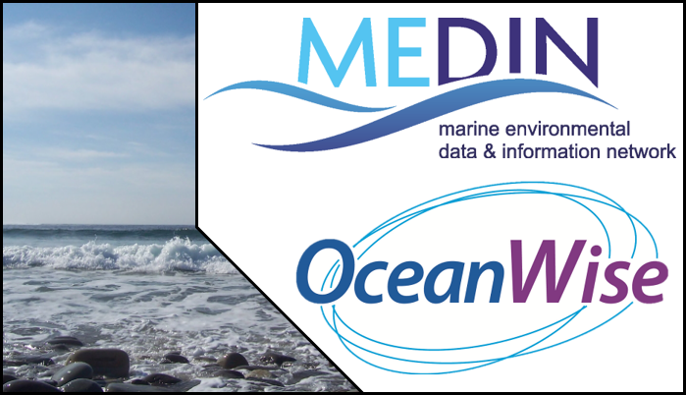

Challenges and Opportunities
This year, we continued our collaboration with the Organisation for Economic Cooperation and Development (OECD) and the Global Ocean Observing System (GOOS) to fill in gaps in our understanding of the value chains of marine data accessible from our Data Archive Centres. 191 people responded to our survey, predominantly from users in the UK but also from a further 19 countries including Australia, Germany, Ireland, Italy and the United States. Collaborating with OECD and GOOS has significantly raised MEDIN’s international profile. This work will conclude in summer 2021 with the release of paper entitled “Value chains in public marine data: a UK case study. A joint OECD STI Working Paper in collaboration with the UK Marine Environmental Data and Information Network (MEDIN) and the Global Ocean Observing System (GOOS) in the Intergovernmental Oceanographic Commission of UNESCO”.

Our users require access to a broad range of marine data services and products in addition to access to raw data that forms the core of MEDIN’s activities. We work closely with UK marine data holders to encourage and help them deliver on their data sharing and publishing objectives. This includes the role of the Data Archive Centres in delivering data products and services.

We explore data management from new technology
This year we funded two small projects to address data management issues associated with new and emerging marine technologies. The first, led by DASSH, addressed archiving, discovering and accessing image and video data within the MEDIN framework and led to the development of the MEDIN Automated Image Management System (MAIMS). MAIMS is a proof of concept, hosted on behalf of the UK marine community by DASSH, the MEDIN Data Archive Centre for species and habitats. The goal was to provide an easy way to submit image datasets to DASSH and for these imagery assets to be associated with accompanying species or habitat data, using MEDIN data guidelines. Users can browse and search for images on the MAIMS and we envisage the content will continue to develop as more images are submitted.

The second of our small projects this year was awarded to the British Oceanographic Data Centre (BODC). BODC can now provide easy, online access to discrete water sample data using a data server called ERDDAP. Water sample data were not previously well exposed through BODC’s online systems. ERDDAP makes it easy for users to access selected water sample data, and has released a lot of previously inaccessible data. By exposing BODC’s discrete measurements in this way, MEDIN users can choose to access the whole dataset within 2 clicks, or choose to subset data, providing dynamic access to BODC data holdings.

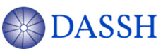ResourceSpace

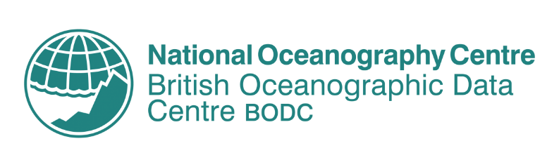ERDDAP

The UK marine community is a large and varied group of organisations spanning government departments and agencies, academia, commercial and industrial partners, and non-governmental organisations to name a few. It is only by working together that we can realise the full financial, scientific and environmental benefits of sharing our marine data. By bringing together the different sectors of the UK marine community, we share knowledge through different channels and provide opportunities for MEDIN Sponsors and Partners to communicate to audiences they may not otherwise access. Communication with these varied stakeholders is key to developing a network that serves all our partners. We raise awareness of MEDIN and spread knowledge of our work throughout the network with high levels of outreach with the marine community and general public. This leads to greater awareness of the importance of marine data management and encourages the improvement of marine data management around the UK and internationally. Our main routes to reach our stakeholders are via our website and social media platforms; our free online newsletter, Marine Data News; through outreach events, conferences and trade fairs; and via the MEDIN YouTube channel.

We engage with our community
A really effective way for us to engage with our users, both existing and prospective, is at conferences, trade fairs and outreach events. This year, these events were held virtually due to the COVID-19 pandemic. During 2020-21, MEDIN and its Data Archive Centres participated in over 36 national and international conferences and trade fairs, by giving presentations, providing a virtual trade stand and sponsoring events. As in previous years, a highlight was participating in the Marine Alliance for Science and Technology for Scotland (MASTS) Annual Science Meeting in October 2020. MASTS used the conference platform software ‘Hopin’, and MEDIN’s virtual stand had 67 visitors over 3 days with an average visiting time of 37 minutes. At MASTS we also gave a virtual poster presentation on MEDIN’s vision and the recent cost benefit analysis of MEDIN’s services. Our virtual booth allowed attendees to access links and information in their own time, and provided an opportunity to showcase the MEDIN animation, which is a light-hearted way to give audiences a better understanding of the importance of marine data management. In January 2021, MEDIN participated in Coastal Futures, which provides a useful opportunity to network with the coastal community.

We share marine data knowledge
This financial year we published 4 issues of Marine Data News, our free online newsletter, featuring articles from MEDIN sponsors and partners. Successfully delivered to at least 530 people, statistics reveal that each publication is opened 396 times on average. With an average of 83 hyperlink clicks, it is clear the newsletter content is relevant and engaging the marine community.
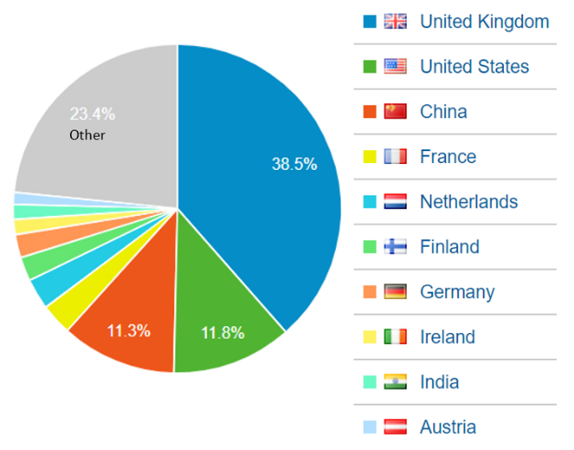
The content on the MEDIN website continues to reach hundreds of countries around the world. This year the top 10 countries accessing our resources included the UK, USA and China (Figure 6). A total of 6,798 users visited the MEDIN website between April 2020 and April 2021. The most popular pages (apart from the MEDIN homepage) were the MEDIN Discovery Metadata Standard and the MEDIN data guidelines pages. There were a total of 2165 downloads from the MEDIN website during the year, which includes MEDIN guidelines, key documents and other resources available for download.
We appreciate the need to employ a range of communication techniques to reach different audiences and this year we developed a series of infographics to portray our vision and benefits in a simple, visual way. One of these is a new “About Us” infographic (Figure 7) and another shows the costs and benefits of MEDIN’s services (Figure 8).
Figure 6 Proportion of users of MEDIN website by country. The ‘other’ segment includes over 120 countries, demonstrating the breadth of our coverage.
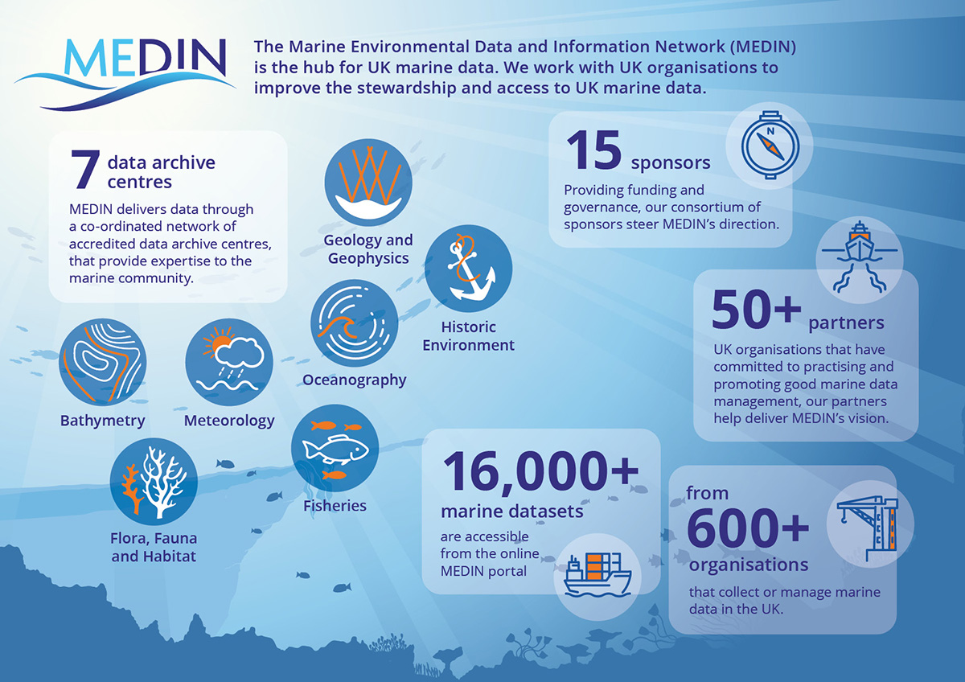
Figure 7: MEDIN’s new “About us” infographic.

We reach new audiences
MEDIN uses online platforms to reach out to new audiences. Our social media outreach has continued to grow substantially since April 2020. We post to LinkedIn and Twitter weekly, updating our followers on our work and sharing marine data information from our partners and sponsors. We increased our Twitter followers by 13% during 2020-21, reaching a total of 1702 at the end of March 2021, whilst MEDIN LinkedIn now has 93 connections and a further 40 followers on the company account. As MEDIN LinkedIn increases in popularity, so do the interactions that take place on the MEDIN profile. The most popular posts are a good indicator of content relevance and shows how we are providing desired information to our audience. This kind of analysis provides useful guidance so we can perfect the different types of content needed for Twitter and LinkedIn.

Challenges and opportunities
The global pandemic has proved challenging for many of our outreach activities, which were previously conducted face-to-face at conferences and trade fairs. However, we have grasped the opportunities to embrace remote conferencing to support the marine community and developed new workflows and habits to accommodate remote working. This has been successful given the circumstances and we are looking towards developing more outreach services remotely where possible.

The seas and coasts surrounding the UK have a complex range of stakeholders who manage, monitor, explore, conserve and sustainably exploit the marine environment. We seek to provide tools and services that support all UK users of marine environmental data. This requires significant coordination to address the (sometimes conflicting) requirements of our users. This work stream provides our partners with overarching coordination, alignment and oversight of marine data management activities in the UK. Long-term strategic planning, annual operational planning and reporting, project and financial management, essential for the success of MEDIN as a collaborative endeavour, are also covered by this work stream.

We provide value for money
Following on from last years’ success in analysing the benefits and costs of MEDIN’s services, this year we developed a method to better understand the users and uses of the data made available from our data centres. This was a collaborative project with the Organisation for Economic Cooperation and Development (OECD) and the Global Ocean Observing System (GOOS), with MEDIN’s involvement funded by Defra. The project provides insight into the value chains of marine data made available from public marine repositories. We will launch the report detailing the results of the project in summer 2021 (Value Chains in Public Marine Data: A UK case study. A joint OECD STI Policy Paper in collaboration with the UK Marine Environmental Data and Information Network (MEDIN) and the Intergovernmental Oceanographic Commission of UNESCO). It provides robust evidence of the breadth of marine data our users are accessing, in order to carry out a plethora of actions. This in turn validates MEDIN’s overarching approach to focus on raw data, without making assumptions about who might use the data for what purpose.

We inform data strategies
This year, we have supported our partners to develop data strategies that align with the ethos of MEDIN. For example, NatureScot (formerly Scottish Natural Heritage) highlight MEDIN in the data management section of their newly published Marine Biodiversity Monitoring Handbook as do the data strategies of the National Oceanography Centre, Natural Resources Wales, and the Joint Welsh Strategy.
To support UK national and international marine reporting responsibilities, such as for the UK Marine Strategy and OSPAR, we provide marine data management advice and support to the key groups involved in marine assessments. In particular, during 2020-21 we supported the Marine Assessment and Reporting Group (MARG) and the four evidence groups that MARG coordinates (the Clean and Safe Seas Evidence Group (CSSEG); the Healthy and Biologically Diverse Seas Evidence Group (HBDSEG); the Productive Seas Evidence Group (PSEG); the Ocean Processes Evidence Group (OPEG), to develop a data strategy for the UK Marine Monitoring and Assessment Strategy (UKMMAS) community. This data strategy is a concise, high level and ambitious summary of the expectations for collecting, using and managing marine data by the UKMMAS community, with the overarching aim to ensure that the marine data produced by the activities falling under the remit of the UKMMAS community are made openly available for long-term access and use.
Of course, we also keep an eye on emerging data strategies that affect our stakeholders. Significant this year, we provided a coordinated, marine-focused response to the UK national data strategy consultation: https://www.gov.uk/government/consultations/uk-national-data-strategy-nds-consultation/uk-national-data-strategy-consultation.

We expand our network
This year we successfully renewed four funding agreements that were coming to an end and said goodbye to Cefas as part of our consortium of funders. Nevertheless, Cefas continues as a very active member of our working groups and is, of course, an important component of the MEDIN Data Archive Centres. Seven of our sponsors have now committed to funding MEDIN until April 2024, which provides financial stability, allowing longer-term planning and decreasing the administrative burden.
Our partners are organisations that commit to best practice marine data management and contribute in kind to delivering our vision. This year we welcomed Narwhal Expeditions; SafetyNet Technologies; Plymouth Marine Laboratory and Project SeaGrass as new partners, taking the total number of partners to fifty-nine. See the full list of our partners here and contact enquiries@medin.org.uk if you are interested in sponsoring or partnering MEDIN.

Challenges and opportunities
This year a range of funding opportunities arose from the UK Research and Innovation Research Councils, that aligned with MEDIN’s remit. MEDIN was approached to provide letters of support for two proposals this year and has had funded costs included in a further two proposals. Although the first two proposals were unsuccessful and the outcome of the latter two is yet unknown, it is reassuring for MEDIN to be approached in this way and provides evidence that there is growing awareness of MEDIN in the broader marine research community.

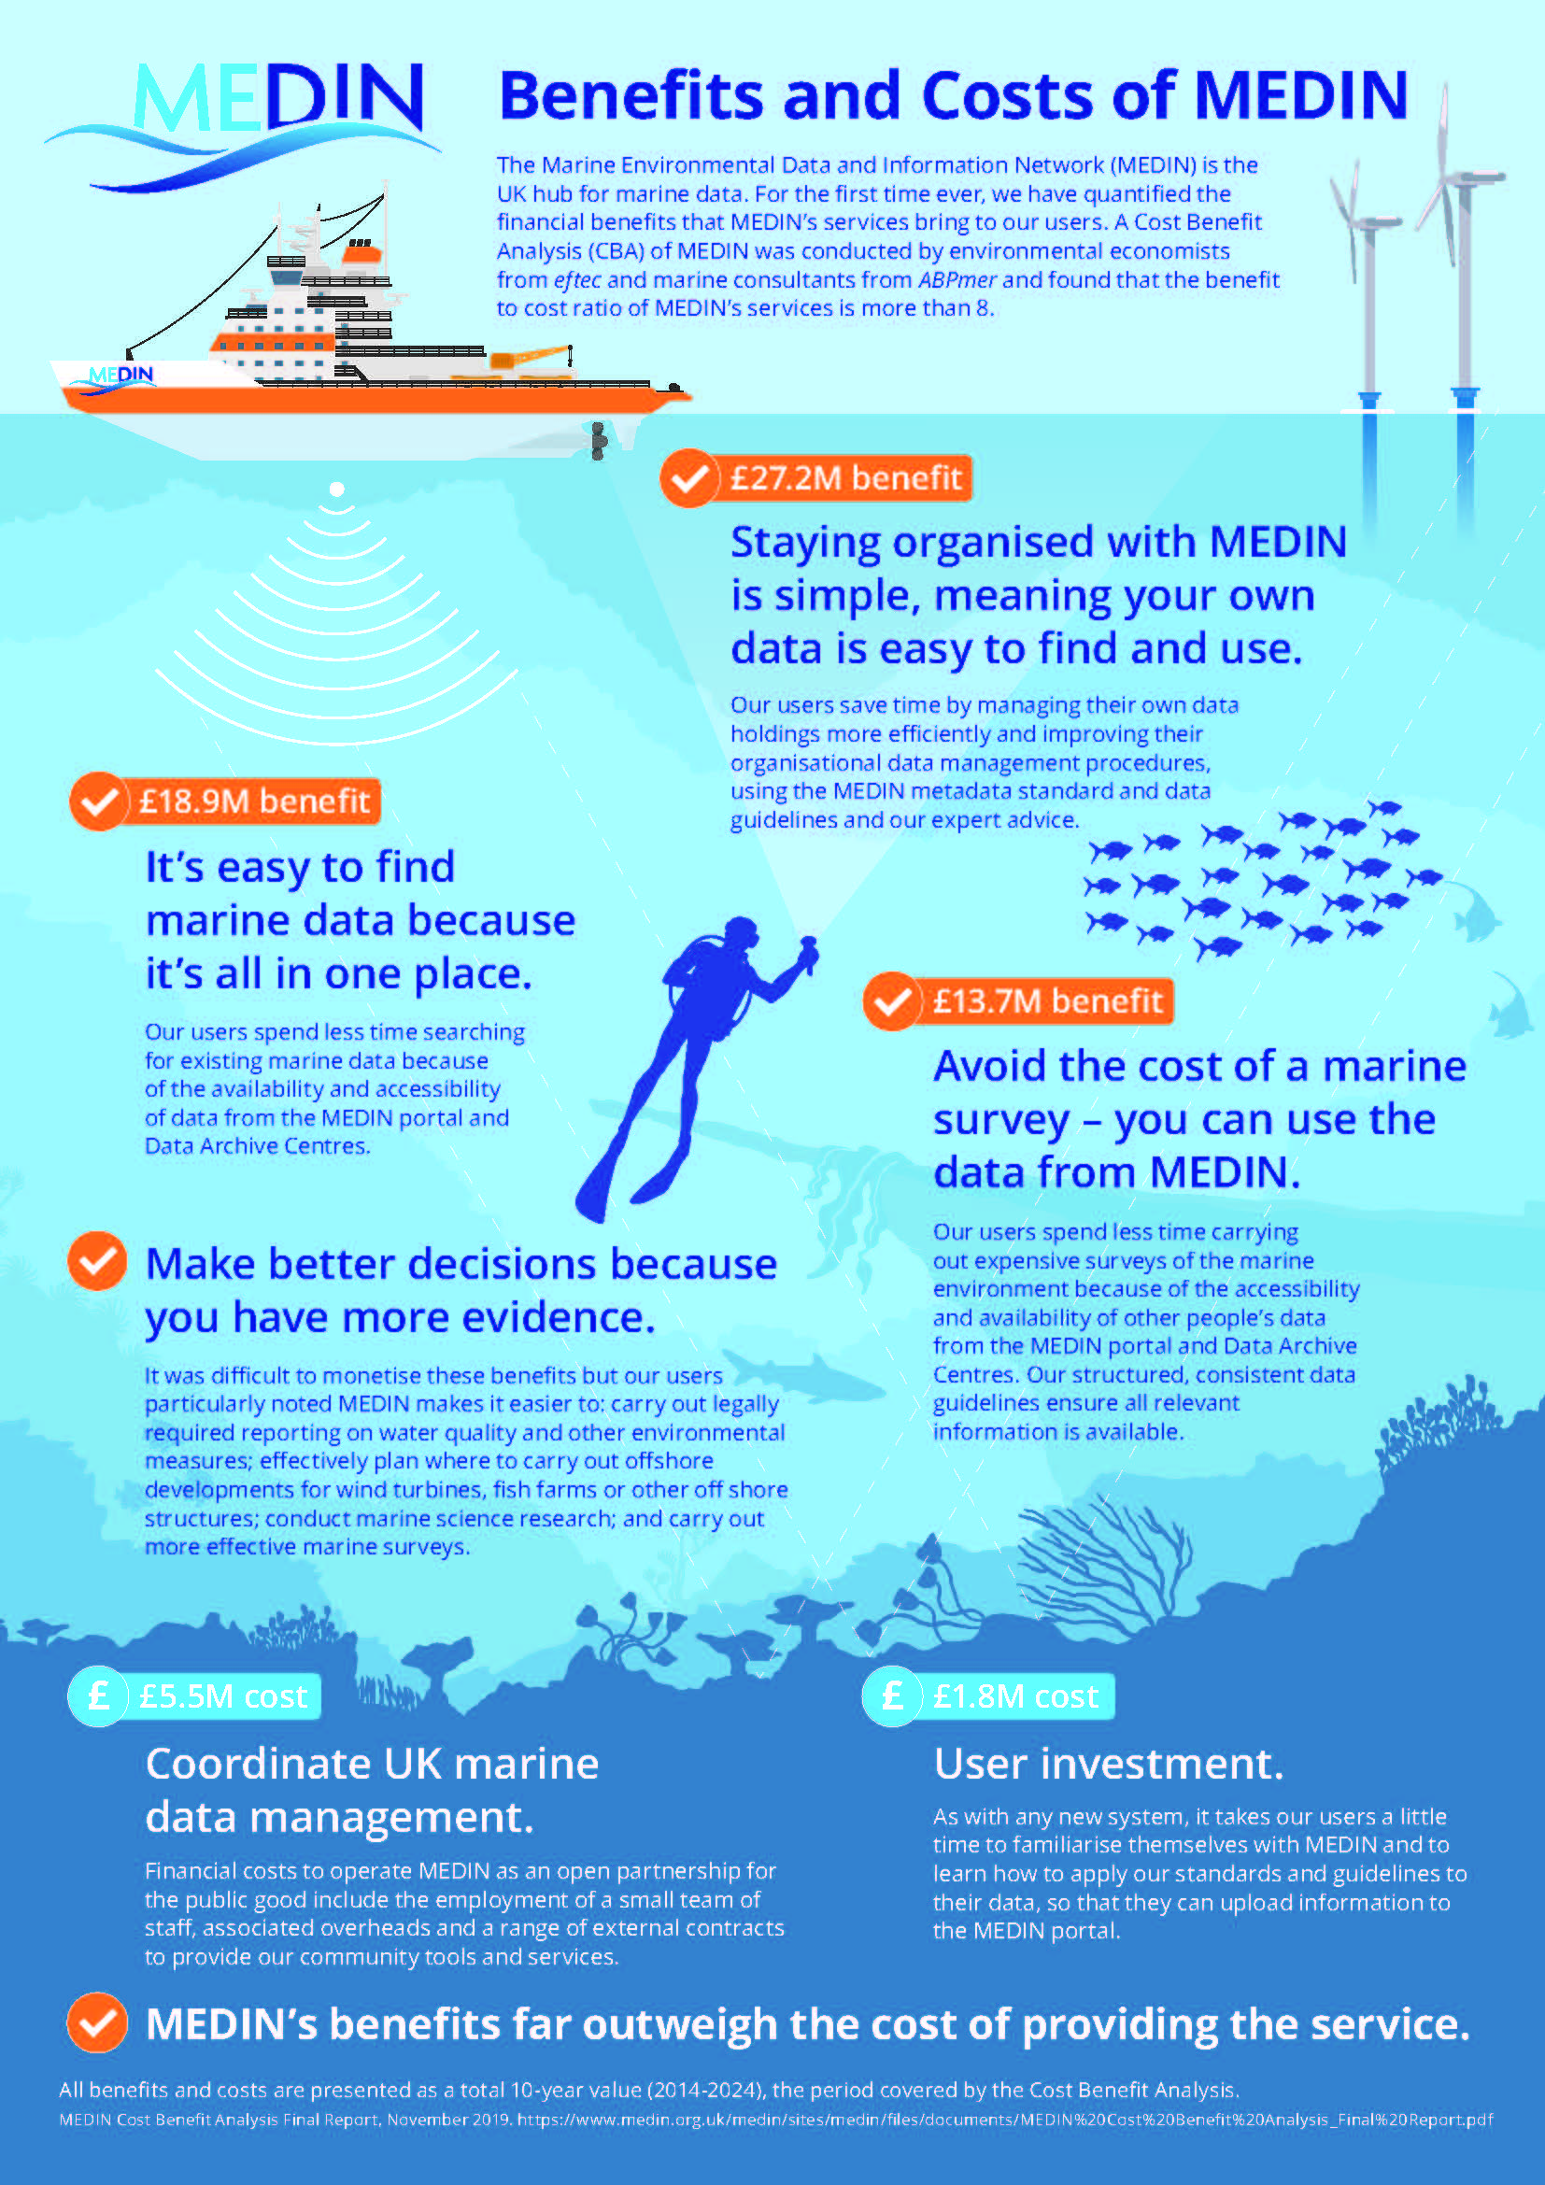
Figure 8: Infographic showing the benefits and costs of providing MEDIN’s services as a total 10-year value (2014-24).

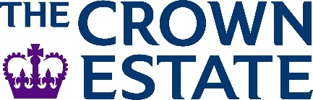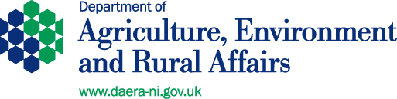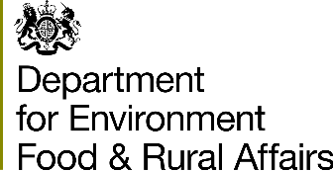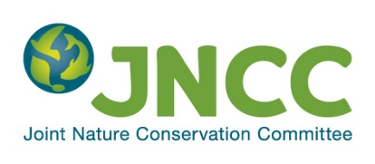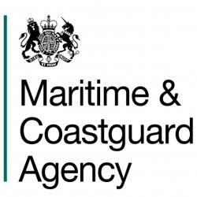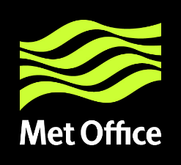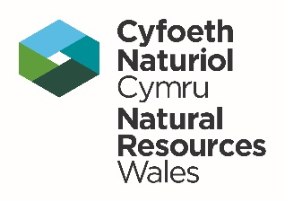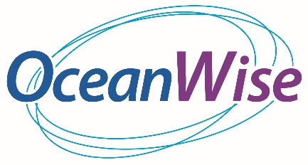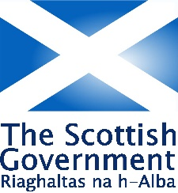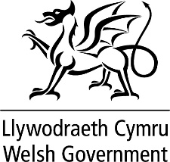

A list of all our partners is available here.

We were unable to capture the number of users of the Data Archive Centres and so this figure significantly underestimates the number of users of MEDIN tools and services. The decrease in the number of users of MEDIN’s services from 2020 to 2021 is partially due to the metrics being used as a proxy for this KPI (in particular, the annual number of downloads of data guidelines and the metadata standard do not capture existing users who have downloaded these resources in previous years). In 2020, the average monthly number of users of the MEDIN portal was higher than usual, linked to an increase in users from China.
* available from a MEDIN Data Archive Centre
£6,600 for 2020-2 to be paid in next financial year.
£9,420 to be paid in next financial year when work is finalised.
£12,524 to be paid in next financial year when work is finalised.
https://medin.org.uk/about/sponsors-and-partners

