MEDIN Business Plan Consultation 1:
We have started the exciting process of writing a new Business Plan for the Marine Environmental Data and Information Network (MEDIN). Over the past year, we have collected stakeholder requirements and, since March, a small group of MEDIN partners have started the process of pulling all those ideas together. We are aiming to have a completed draft ready for November 2023 and plan to consult you at each stage of drafting.

So, as a first step, this document details MEDIN's draft vision, mission, goals and high-level objectives for 2024-2029. You are invited to review these with your colleagues and leadership team to ensure that these strategic areas will meet your organisation’s needs for MEDIN over the next five years.

Please provide your organisation's coordinated feedback using the accompanying spreadsheet by 28th July 2023. Feedback should be emailed to Clare Postlethwaite (cfpo@noc.ac.uk)

Further consultations on other aspects of the MEDIN Business Plan will follow.

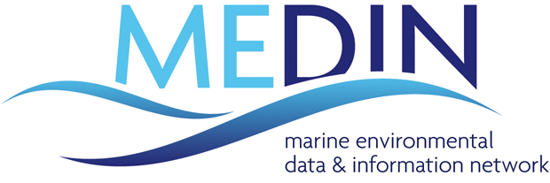

Business Plan

2024-2029

Measure once, use many times

Authors: Clare F Postlethwaite, Rohan Allen, Graeme Duncan, Gaynor Evans, Laura Hanley, Laura Hewson, Dan Lear, Kieran Millard, Charlotte Miskin-Hymas, Roseanna Wright

Vision, mission and strategic goals

Vision
Our vision is that UK marine data are findable, accessible, interoperable and reusable.

Mission
Our mission is to maximise the value of the UK’s marine data, providing solutions for their efficient capture, archive, access and reuse, to increase the understanding of our marine environment and support the sustainable development of the blue economy.

Strategic goals
We have set three major goals to help deliver our vision:

A | We deliver our vision for all of the UK marine community by providing tools and services that are beneficial across the wide spectrum of the marine data community and the full data lifecycle; ensuring widespread archiving and open access to high-quality data to enable maximum use and security and to provide integration and coordination of services. | Adoption and organisation
B | We deliver the technical infrastructure required to ensure the UK’s marine environmental data are Findable, Accessible, Interoperable and Reusable (FAIR) by providing: a coordinated network of marine Data Archive Centres; a single portal to access all UK marine data and standards; tools and services to support the UK marine community. | Technical infrastructure
C | We deliver an open and constructive data management culture, fostering global collaboration and partnerships, addressing skills gaps, and providing training and education. | Community and education

High Level Objectives
We have defined 10 High Level Objectives (HLOs) for 2024-2029 to help achieve our goals. All of these are a continuation of objectives set in previous MEDIN Business Plans, as they remain relevant.
1 | Access to data. Provide efficient access to arguably the most comprehensive coverage of high-quality marine data held by UK organisations via the MEDIN portal and DAC network, thereby enabling wide-ranging, coordinated and dynamic access to UK marine data, UK marine reference data, view and download services and other data products in line with user requirements.
2 | Smooth archival. Facilitate frictionless, secure, cost-effective, long-term archiving of marine data within the MEDIN DAC network.
3 | Tools and standards. Develop and provide an open access suite of easy to use, forward-looking data management tools and standards e.g. data guidelines, metadata standard, Application Programming Interface (API) guidance, fostering community sharing of expertise and code, to ensure more efficient handling of all marine data generated now and in the future.
4 | Community leadership. Lead and build a community of engaged users of marine data, fostering good data management practice, promoting open data principles and the widespread adoption of the MEDIN framework.
5 | Environmental assessments. Facilitate domestic and international assessments of the marine environment through the storage, management and dissemination of UK monitoring data and provision of advice on retrieval and amalgamation of large, multidisciplinary datasets.
6 | Data interoperability. Support the UK marine sector to implement globally and cross-domain interoperable marine data services, e.g. machine-readable Application Programming Interface (API) for DACs and others.
7 | Data from new technologies. Lead the UK marine community in data management for new and emerging technologies, including autonomous and robotic systems.
8 | Monitoring. Record and provide access to information on monitoring activities in the UK to support the UK Marine Monitoring and Assessment Strategy (UKMMAS) community.
9 | Skills and education. Enhance data management skills within the marine community, providing training and education.
10 | International influence and coordination. Integrate, coordinate and influence international and cross-domain data initiatives, promoting good data management practice.

MEDIN’s High Level Objectives (HLOs) for 2024-2029.

