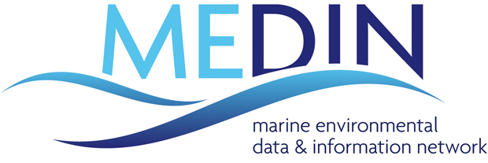

Business Plan

2024-2029

Measure once, use many times

Authors: Clare F Postlethwaite, Rohan Allen, Graeme Duncan, Gaynor Evans, Laura Hanley, Laura Hewson, Dan Lear, Kieran Millard, Charlotte Miskin-Hymas, Roseanna Wright

Contents
1. Introduction 3
1.1 National framework 5
MEDIN Data Archive Centres 5
MEDIN Portal 5
MEDIN discovery metadata standard 5
The Network 6
1.2 Looking back 6
1.3 Looking to the future: The 5-year plan 8
1.4 User stories 9
2. Vision, mission and strategic goals 12
2.1 Vision 12
2.2 Mission 12
2.3 Strategic goals 12
3. Drivers and objectives 13
3.1 Drivers 13
3.1.1 UK marine data coordination for a marine nation 13
How we will address this driver: 13
3.1.2 Marine data for monitoring and assessment 14
How we will address this driver: 14
3.1.3 Marine data for developing policy 14
How we will address this driver: 15
3.1.4 Marine data for sustainable industrial growth 15
How we will address this driver: 15
3.1.5 Marine data in a changing technological landscape 16
How we will address this driver: 16
3.2 High Level Objectives 16
4. Delivery and funding 18
4.1 Delivery 18
4.2 Funding 18
Appendix A – SWOT analysis of MEDIN 20
Appendix B – Contributors 23
Appendix C – Policy drivers 25

Introduction

The United Kingdom has a complex range of stakeholders who manage, monitor, explore, research, conserve and sustainably exploit the marine environment. The Marine Environmental Data and Information Network (MEDIN) is a collaborative and open partnership, established in 2008 to provide a national framework for managing the valuable marine data and information collected and used by those stakeholders. MEDIN supports all members of the UK marine community, a task requiring significant coordination, underpinned by widespread engagement across both the public and private sectors and an emphasis on skill sharing throughout the network.

Marine data can be expensive and challenging to collect, are always unique with respect to time and location and often need to be collected alongside significant volumes of contextual, cross-discipline data to be useful. This complexity was one of the fundamental drivers for establishing MEDIN as the hub for all UK marine data. Alongside this is the understanding that there are widespread commercial, scientific and conservation benefits to be gained from working together to effectively manage and share these data. These benefits have been recognised since MEDIN’s inception in 2008, but it is only since 2019 that it has been possible to quantify these benefits. Evidence collected by environmental economists eftec and marine consultants ABPmer for an independent cost benefit analysis showed that the benefits of MEDIN’s services far outweigh the costs of running the network, with a ratio of 8:1. The analysis found the four main benefits that the UK marine community gained from MEDIN’s services over a ten year period were £18.9 million savings from making data easier to find; £27.2million savings by helping organisations stay organised and manage their own data more efficiently; £13.7million savings from users finding they can avoid undertaking expensive new marine surveys because the data they need already exists; and an unquantified but nevertheless significant benefit of users making more informed decisions because of a broader evidence base.

MEDIN’s strapline ‘measure once, use many times’, captures the ethos of MEDIN and has been adopted by other organisations and networks around the world. In the next period, MEDIN will continue to both develop and improve its resources, adopting a more agile approach to seeking funding and contributing fundamentally to the marine evidence base for the benefit of the UK economy.

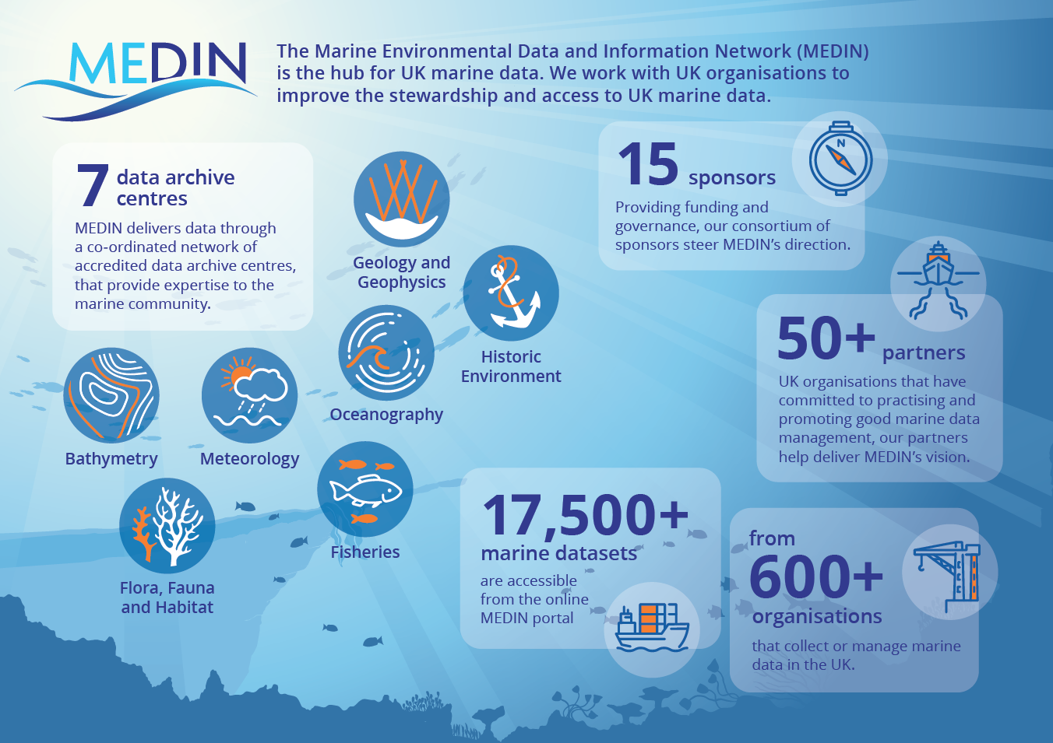
Figure 1. Infographic showing key features of the Marine Environmental Data and Information Network

National framework
MEDIN has established a national framework for providing access to, and management of, marine environmental data and information. These data are collected or owned by UK organisations, predominantly within UK territorial waters but also on a global scale. The framework consists of three main components:
- An operational suite of coordinated, accredited and specialist MEDIN Data Archive Centres (DACs).
- A comprehensive online portal to make it easy to find UK marine data.
- A discovery metadata standard and data guidelines, to ensure all relevant information about a dataset is captured and findable by potential users.

MEDIN Data Archive Centres
A wide range of marine data are managed and delivered by MEDIN’s operational network of specialist Data Archive Centres (Figure 1), hosted and run by some of the UK’s key marine stakeholders. MEDIN DACs undergo a stringent accreditation process, ensuring quality data management services for our users. Our DAC network provides valuable expertise and advice to the marine community, as well as collaboratively facilitating data and metadata flows to international data initiatives. This greatly expands the potential user base for UK marine data, thereby increasing the impact those data could have when reused. The MEDIN DAC network will continue to grow as resources and drivers are identified to address known gaps.

MEDIN Portal
The MEDIN discovery metadata portal is an online portal designed to make it easy for users to find UK marine data. Currently providing access to over 17,500 metadata records from more than 600 different organisations, the MEDIN portal is the most comprehensive of its type nationally. The wide variety of data types catalogued in the MEDIN portal have been collected for a range of scientific, policy, conservation and commercial purposes. The portal aligns with the Findable component of the FAIR data principle (Wilkinson et al, 2016), enabling marine data to be discovered by anyone, alongside all the standardised information about those data (the metadata) that would be required to re-use the data in the future, without needing to contact the person who collected those data.

MEDIN discovery metadata standard
The MEDIN discovery metadata standard is a set of rules and guidance that standardises the capture of all relevant information about a dataset, to allow a potential user to find and subsequently make an informed decision about best use of that dataset. Recognising that marine data cannot always be described in the same way as terrestrial data, MEDIN established this standard to support the marine community to be UK GEMINI and INSPIRE compliant. This community-derived standard is continually updated, along with a suite of user-friendly metadata creation tools, easing the archival process for data submitters whilst maintaining best governance practice and ensuring that archival standards are maintained.

The metadata standard is supported by a suite of data guidelines, which encourage the standardised and interoperable submission and storage of data, and which are continually being updated and sourced from external expert groups where suitable.

MEDIN provides support and shared skills across the partnership to interpret and implement national and international standards and guidelines for marine data. This enables integration of datasets at a national level and between public and private sectors. Moreover, our standards and guidelines facilitate data flows between organisations and onwards internationally.

The Network
MEDIN provides a coherent and vibrant networking forum for the marine data community as a whole. Our common and interconnected pool of data expertise allows a rare opportunity for best practice end expertise to be shared through common issues and topics. MEDIN continues to provide the means for a unified marine voice in wide reaching data initiatives and work areas. Commonly called upon to act as a facilitator and exemplar of data expertise in external work programmes, MEDIN’s reputation as an independent broker for marine data community remains strong. This is relevant both for long-established groups, such as the UK Marine Monitoring and Assessment Strategy (UKMMAS) community, and more recently-established groups, such as the Centre for Seabed Mapping, where MEDIN provides expertise and marine data management advice.

MEDIN works with the different sectors involved with marine data and information to find solutions that meet their needs. As an example from the policy sector, MEDIN manages the UK Directory of Marine Observing Systems (UKDMOS), a unique and detailed catalogue of long-term UK monitoring activities, on behalf of the policy-driven UKMMAS community. We also provide support and advice to cross-sectoral initiatives, such as the Fisheries Industry Science Partnerships (FISP) scheme and industry-specific initiatives, such as the Offshore Wind Evidence and Knowledge Hub, demonstrating our sector agnostic approach.

1.2 Looking back

In April 2023, MEDIN celebrated fifteen years since its inception and took the opportunity to reflect on some key milestones (Figure 2). The success of MEDIN over the last fifteen years can perhaps best be measured through the broadening and strengthening of the partnership. Going from an initial group of four Data Archive Centres sharing 800 datasets in 2010 to a mature network that shares over than 17,500 datasets owned or managed by more than 600 different organisations across sectors in 2023, is a remarkable feat. The breadth of the partnership is reflected in the organisational membership of the MEDIN Working Groups, which work hard to ensure all viewpoints are considered in the overall strategic direction of the network.

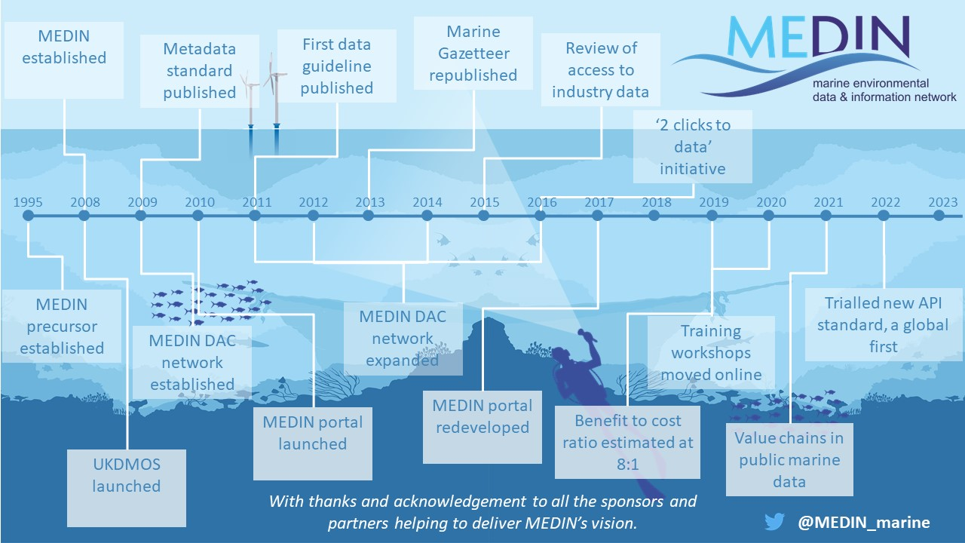
Figure 2 Key milestones for the Marine Environmental Data and Information Network over the past fifteen years.

The growth of the partnership has been facilitated through our highly successful workshops and training. In 2020 a new, online version of MEDIN’s training workshop entitled ‘Marine Data Management, Governance and the MEDIN toolset’ was developed in collaboration with MEDIN sponsor OceanWise, and delivered using the UN Ocean Decade-endorsed Ocean Teacher Global Academy platform. These online workshops have so far welcomed nearly 200 participants from almost 100 organisations and 31 countries.

Maintaining focus on recent highlights, it is clear that MEDIN has continued to actively seek new ways to improve the marine data landscape and to recognise the value of marine data to the global economy. Just as the MEDIN portal provides the focal point to discover UK marine metadata mobilised through the MEDIN Network, a natural next step in the evolution of harmonised access to marine data is to provide a single point of access to data (rather than to its metadata). Recognising the benefits such a development would have to users of marine data, MEDIN piloted a possible means to provide such a service. As far as we are aware, MEDIN were the first in the world to trial the Open Geospatial Consortium’s Environmental Data Retrieval Application Programming Interface (OGC EDR API) with marine data. This innovation was funded by MEDIN and led by three of the MEDIN DACs and led to widespread international interest in MEDIN. This work has the possibility of making a step change in how easy it is to access data from many organisations.

Another piece of work that demonstrated major international recognition of MEDIN’s expertise was a collaboration with the Organization for Economic Cooperation and Development (OECD) and the Global Ocean Observing System (GOOS). It has long been recognised that marine data have significant reuse value beyond the purpose for which they were originally collected but up until recently it has been extremely difficult to quantify that value in monetary terms. In 2019, OECD, GOOS and MEDIN worked together to establish a method to explore value chains in marine data. This work provided evidence that public marine data have complex and varied value chains, with multiple industries and sectors of the UK’s ocean economy using marine data made available through public repositories (Jolly et al, 2021). This work will ultimately lead to OECD being able to quantify the value of the reuse of marine data.

MEDIN’s aspirational and ambitious new 5-year business plan builds upon the successes of the past and will see MEDIN strengthen its position as an internationally recognised authority on marine data management. By setting out a framework of strategic goals and deliverable activities, this plan captures MEDIN’s objectives and aspirations for its next half-decade.

1.3 Looking to the future: The 5-year plan

This document outlines MEDIN’s plan for the next five years and sets out an ambitious and targeted programme to tackle the key data management objectives identified by our stakeholders in a changing data landscape. Delivery of this plan will see MEDIN continue to provide measurable benefits to the UK economy, providing services, tools and expert advice, agnostic of the sector our users work in. Recognised as an independent broker, MEDIN will lead the marine data community and facilitate connections based on shared experience. We will advocate best practice marine data management throughout the data lifecycle, supporting our partners at all stages of their organisations’ data maturity. As the flagship for managing UK marine data, we will provide the services that underpin a mature data infrastructure, with inbuilt flexibility to react to change, opportunities and innovation.

Marine data form an integral part of the UK data ecosystem, and MEDIN will act as the national focal point for deriving maximum impact from these data. We will continue to highlight the crucial role that marine data play in our everyday lives and the significance, therefore, of ensuring that our valuable marine data are findable, accessible, interoperable and reusable (FAIR). We recognise the need to ensure greater recognition of the network and will work with our partners to achieve this.

1.4 User stories

One of the challenges MEDIN faces is delivering a service that benefits the whole of the UK marine community, which has broad, disparate and sometimes conflicting needs and priorities. MEDIN users typically fall into five categories: Government departments and agencies, commercial organisations, academic organisations, charities/Non-Governmental Organisations and members of the public. We provide all our users with free and open access to the most comprehensive array of UK marine environmental data, regardless of the sector they work in. Moreover, we provide the training, tools and support they need to improve how they manage their marine data and make their data Findable, Accessible, Interoperable and Reusable (FAIR). These user stories demonstrate some of the ways that MEDIN helps our wide range of users.

Vision, mission and strategic goals

2.1 Vision
Our vision is that UK marine data are findable, accessible, interoperable and reusable.

2.2 Mission
Our mission is to maximise the value of the UK’s marine data, providing solutions for their efficient capture, archive, access and reuse, to increase the understanding and sustainable management of our marine environment and support the sustainable development of the blue economy.

2.3 Strategic goals
We have set three major goals to help deliver our vision:

A | We deliver our vision for all of the UK marine community by engaging with our stakeholders; providing tools and services that are beneficial across the wide spectrum of the marine data community and the full data lifecycle; ensuring widespread archiving and open access to high-quality data to enable maximum use and security and by providing integration and coordination of services. | Adoption and organisation
B | We deliver the technical infrastructure required to ensure the UK’s marine environmental data are Findable, Accessible, Interoperable and Reusable (FAIR) by providing: a coordinated network of marine Data Archive Centres; a single portal to access all UK marine data and standards; tools and services to support the UK marine community. | Technical infrastructure
C | We foster an open and constructive data management culture, encouraging global collaboration and partnerships, increasing awareness and engagement, addressing skills gaps, and providing training and education. | Community and education

Drivers and objectives

3.1 Drivers

Marine environmental data underpin some of our world’s most critical services and affect all our lives, without us necessarily realising it. For example, in the UK, the food we eat, the energy we use to run our buildings, the phones and internet access we take for granted, and the reassurance that our homes and businesses are protected from coastal flooding all rely on marine environmental data. This is because marine data are crucial for weather and climate forecasts, which inform the global farming community; are critical to safely operate our offshore energy generating facilities, our sub-seabed communication cables, international maritime trade and fisheries industries; and are essential for predicting and preventing hazards such as coastal flooding, tsunamis and sea level rise. Moreover, marine data provide the evidence we need to make sustainable decisions about the management of our marine resources, such as where to site new infrastructure, which resources can be sustainably extracted and which need conservation measures put into place. Marine data are pivotal to our understanding of the climate crisis and will likely play an increasingly important role in some of the world’s efforts to mitigate the effects of the crisis e.g. offshore renewable energy generation, carbon dioxide capture.

MEDIN plays a crucial role in coordinating UK marine data management, across policy, industry and academic sectors. The network facilitates the delivery of cross-cutting ambitions for UK marine data, taking into account diverse drivers across our broad range of stakeholders. The marine data landscape is continuously developing, including the introduction of innovative new data collection methods, and challenges, and an understanding of the importance of data products and models. Demand for marine data is increasing, with policy, academic, and industry stakeholders seeking to develop a systems-level view of the marine environment. MEDIN will continue to use its technical infrastructure, development of data management best practices, and community and education tools to increase expertise across UK and international communities.

3.1.1 UK marine data coordination for a marine nation
MEDIN is uniquely positioned to act as a central network for UK marine data coordination, cutting across administrations, organisations, and sectors. This is particularly important following EU Exit, devolution and the UK’s position as an independent marine nation. MEDIN must continue to display leadership in marine data at a UK level, contributing to regional and international initiatives as appropriate.

How we will address this driver:
MEDIN will continue to provide the national framework for managing UK marine data, which includes a federated network of specialist and accredited thematic Data Archive Centres, a suite of standards and guidelines to provide consistent ways to operate and a centralised discovery portal to give users a single place to go to access UK marine data owned or managed by over 600 organisations.

MEDIN will continue to act as the UK hub for marine data and metadata, exchanging (meta)data between UK and international infrastructure to support scientific collaboration, and thereby increasing the impact and value of UK data. MEDIN DACs will continue to regularly submit data to international data repositories on behalf of the UK marine community e.g. International Council for the Exploration of the Seas (ICES), the Global Biodiversity Information Facility (GBIF) and will start to provide meta(data) to the UN decade for Ocean Science-endorsed Ocean InfoHub (OIH) infrastructure, provided by the Intergovernmental Oceanographic Commission’s (IOC’s) International Oceanographic Data Exchange (IODE).

In 2022, MEDIN’s parent body, the Marine Science Coordination Committee (MSCC) was dissolved. In preparation for the 2024-2029 business cycle, MEDIN is exploring opportunities to identify a new parent body that will help the network maximise its impact across UK marine data and can provide a mechanism for MEDIN to feed into government.

3.1.2 Marine data for monitoring and assessment
The UK is steward to over 880,000 km² of marine environment, by seafloor area. MEDIN supports the UK government by providing expert advice to the UK Marine Monitoring and Assessment Strategy (UKMMAS) community, which coordinates monitoring in the marine environment at a UK level to meet statutory obligations, and in particular the UK Marine Strategy Regulations 2010. Long-term monitoring is used to identify and understand any changes to the systems being monitored.

How we will address this driver:

MEDIN Data Archive Centres and Partners will continue to provide long-term access to data from statutory monitoring programmes and will increasingly do this in near-real time. These data provide the underlying evidence for UK Marine Strategy and OSPAR assessments.

MEDIN will continue to manage and monitor the use of the UKMMAS marine data strategy and its associated implementation plan, designed to describe practices for collecting, using and managing marine data collected by the UKMMAS community. This will ensure that monitoring data are made openly available for long-term access and use, yielding economic, societal and scientific benefits.

MEDIN will continue to manage, maintain and develop the most comprehensive catalogue of UK monitoring activity in the UK, allowing us to understand what regular monitoring is undertaken of our coasts and seas, avoiding duplication and encouraging collaboration.

3.1.3 Marine data for developing policy
The UK Government Industrial Strategy 2017 and 25 Year Environment Plan set out the approach to safeguarding our environment and future-proofing our economy for generations to come. To achieve the ambitions and targets requires solid foundations: comprehensive, reliable data, strong governance, a robust delivery framework, and everyone to play their part.

How we will address this driver:

MEDIN provides a mature framework and governance structure for marine data and is well placed to advise other sectors as they start to develop in this area. MEDIN will continue to provide a consolidated, cross-UK and cross-sectoral marine view on data policies, taking into account the specific challenges of working with marine data.

MEDIN’s activities support UK marine management and science policy arising from many international, regional and national policy drivers. The key policy drivers are listed in Appendix C. MEDIN will continue to support these policy drivers by tackling key marine science priorities and providing streamlined access to, and onward dissemination of, data collected for monitoring programmes e.g. UK Marine Strategy and the Oslo and Paris Convention (OSPAR).

MEDIN Data Archive Centres and the wider partnership will continue to provide long-term access to a broad range of marine environmental data, such as are required to both understand and quantify ecosystem services and natural capital, leading to an understanding of marine societal benefits.

MEDIN will continue to provide infrastructure to support the Government’s “Open Data Agenda” via such platforms as data.gov.uk and Scottish Spatial Data Infrastructure, Welsh Government Open Data Portal as well as supporting our Partners to meet national and international standards e.g. INSPIRE, GEMINI and ISO19115.

3.1.4 Marine data for sustainable industrial growth
The seas around the UK are set to get busier over the coming decades and the footprint of offshore industries is increasing in response to initiatives such as the British Energy Security Strategy and the Net Zero Strategy. As the marine sector expands, so does the volume of industry data being generated to support the development of projects and to understand the environmental baseline. Marine industries are also seeking to re-use existing data to fulfil greater evidence needs and to reduce carbon emissions, costs and timeframes. Value chain analysis for UK marine data conducted by the Organization for Economic Cooperation and Development (OECD), the Global Ocean Observing System (GOOS) and MEDIN, demonstrates the profound impact of public marine data on industrial growth.

How we will address this driver:

MEDIN will continue to operate a centralised discovery portal to give industry a single place to go to access UK marine data and will increasingly work with industry and data owners to maximise discoverability of relevant data to support marine industries and sustainable development. Through the discovery portal, MEDIN will increasingly look to expand the links to other key data platforms regularly utilised by industry.

MEDIN’s Data Archive Centres, and the wider partnership, will continue to promote the benefits of open data and provide long-term access to marine data that can support offshore and coastal development, whilst also enabling decision makers to have access to the best available data and evidence.

MEDIN will continue to provide and maintain up-to-date data standards and guidelines that can be adopted by industry to ensure that data collected by industry is reusable and interoperable. In turn these data standards can help to increase value for industry by reducing the need to recollect survey data.

3.1.5 Marine data in a changing technological landscape

We are in a period of technological change, both in terms of the ways marine data are collected, but also in terms of how those data go on to be used. Technology expedites and broadens the volumes of data that are generated from marine surveys and observations, enhancing our understanding of the world and presenting challenges for our data centres. We see technologies developed in other domains being modified or adapted to be applied within the marine domain. For example, Artificial Intelligence (AI), machine learning-based approaches and the automation of data collection are presenting challenges with the scale and rate of data generation, which will continue into the foreseeable future.

How we will address this driver:

The expertise within the MEDIN partnership contributes to an extensive awareness of advances in technology. Through discussions across the network and engagement with the wider community we will ensure new and emerging technologies are identified and appropriate action taken.

The ever-increasing volumes of data being generated through automated acquisition, AI and machine learning approaches and related technologies will put additional demands on the network of MEDIN Data Archive Centres. By ensuring routine reviews, horizon scanning and appraisal of the emerging landscape, MEDIN will be positioned to respond in a timely, relevant and cost-effective manner.

MEDIN and its network of partners and high-level of domain expertise is well placed to engage with technological developments and ensure the benefits are conveyed to the wider marine community. We will communicate new opportunities with the wider partnership and continue to provide guidance on adoption and implementation where relevant.

High Level Objectives
We have defined 10 High Level Objectives (HLOs) for 2024-2029 to help achieve our goals. All of these are a continuation of objectives set in previous MEDIN Business Plans, as they remain relevant. There are cross-cutting links across many of these objectives, reflecting the holistic approach that MEDIN takes.
1 | Access to data. Provide efficient access to the most comprehensive coverage of high-quality marine data held by UK organisations via the MEDIN portal and DAC network, thereby enabling wide-ranging, coordinated and dynamic access to UK marine data, UK marine reference data, view and download services and other data products in line with user requirements.
2 | Smooth archival. Facilitate frictionless, secure, cost-effective, long-term archiving of marine data within the MEDIN DAC network.
3 | Tools and standards. Provide an open access suite of easy to use, forward-looking data management tools and standards, expanding these if required, fostering community sharing of expertise and code, to ensure more efficient handling of all marine data generated now and in the future (e.g. data guidelines, metadata standard, Application Programming Interface (API) guidance).
4 | Community leadership. Lead and build a community of engaged users of marine data, fostering good data management practice, promoting open data principles and the widespread adoption of the MEDIN framework.
5 | Environmental assessments. Facilitate domestic and international assessments of the marine environment through the systematic storage, management and dissemination of UK monitoring data and provision of advice on retrieval and amalgamation of large, multidisciplinary datasets.
6 | Data interoperability. Support the UK marine sector to implement globally and cross-domain interoperable marine data services, e.g. machine-readable Application Programming Interface (API) for DACs and others.
7 | Data from new technologies. Lead the UK marine community in data management for new data types and emerging technologies, including sensor networks and autonomous and robotic systems.
8 | Monitoring. Record and provide access to information on monitoring activities in the UK and support the UK Marine Monitoring and Assessment Strategy (UKMMAS) community with expert advice.
9 | Skills and education. Enhance data management skills within the marine community, providing and signposting training and education for all levels of experience.
10 | International influence and coordination. Integrate, coordinate, and influence international and cross-domain data initiatives, sharing good data management practice.

MEDIN’s High Level Objectives (HLOs) for 2024-2029.

4. Delivery and funding

4.1 Delivery
The governing body for MEDIN is the MEDIN Sponsors’ Board. Membership includes one representative per sponsoring organisation. This is the ultimate decision-making body, responsible for approving the Business Plan, operational work plans and budgets. The MEDIN Executive Team provides operational support to the Sponsors’ Board and is comprised of the MEDIN Core Team, four sponsor representatives and four thematic experts. Membership to the Executive Team is by agreement of the Sponsors’ Board and the existing Executive Team. Previously the MEDIN Chair was appointed by the Marine Science Co-ordination Committee (MSCC). As MSCC is no longer extant, the MEDIN Chair will be appointed by the MEDIN Sponsors’ Board through an open and transparent selection process with the promotion of diversity seen as desirable. The MEDIN Chair role will be a rotating position, with a new Chair appointed every 5 years in alignment with each Business Plan cycle.
An operational work plan will be developed for each year of this Business Plan, and will include detailed deliverables, Key Performance Indicators (KPIs) and a comprehensive account of costs. The operational work plan will incorporate activities identified as contributing to MEDIN’s High Level Objectives (HLOs) as outlined in the supplementary material accompanying this Business Plan. These activities are subject to change, dependent on emerging initiatives and priorities, reflecting the high rate of development in the data infrastructure sector. The MEDIN Sponsors’ Board will be responsible for signing off the operational work plan.

In line with previous MEDIN Business Plans, MEDIN will utilise seven Work Streams (WS) in the delivery of its operational work plan. Each work stream will be coordinated by the MEDIN Core Team, which consists of staff based at the British Oceanographic Data Centre (BODC) within the National Oceanography Centre (NOC). Work streams will be supported by Working Groups, consisting of MEDIN partners from across the marine sector with expertise and interest in specific areas and co-chaired by thematic experts selected by the Executive Team. MEDIN will also establish Short-Term Activity Groups (STAGs), which will be responsible for delivering time-bounded projects. STAGs will include experts from within MEDIN partner organisations to advance projects at pace. Working Groups and Short-Term Activity Groups report to the MEDIN Executive Team, facilitating input from the wider partnership to the delivery of MEDIN’s work.

4.2 Funding
MEDIN is funded by a consortium of sponsors and further supported by in kind contributions from a broad range of partner organisations. All of the UK marine community are welcome to be part of the network as Sponsors or Partners and all members are invited to contribute to delivering this collaborative Business Plan. The MEDIN Sponsors provide the financial backing required for maintenance and development of MEDIN either via the work of the secretariat (MEDIN Core Team), contributory coordination funding for the Data Archive Centres and via the tools and resources MEDIN provides our users for free (website, portal, standards, data guidelines, metadata editors, etc.) In addition to the capital funding, significant support is provided by sponsor and partner organisations through in-kind resource contributions. This resource, provided through both staff time within the Working Groups and undertaking of MEDIN-adjacent projects, is fundamental to MEDIN’s success and continuing viability. Moreover, without the core capability funding of each MEDIN Data Archive Centre from their host organisation or funders, the MEDIN framework would no longer be feasible.

MEDIN’s consortium of sponsors represent Government, academic, charitable and private-sector organisations. During the period 2019-2024 MEDIN operated with an annual budget of ~£512K, which reflected a continued decrease in funding since MEDIN’s inception in 2008. This Business Plan outlines ambitions for MEDIN that will require greater financial resources to be secured throughout the 2024-2029 period, particularly where infrastructure investment is required.
An increase in overall funding is therefore required to deliver the full ambition of this business plan.
Therefore, in addition to sustained funding commitments, MEDIN will work with its consortium of sponsors and other funding organisations to proactively seek capital investment for specific development projects. Furthermore, MEDIN will continue seeking to expand its consortium of sponsors, with a focus on under-represented sectors.
MEDIN provides a detailed work programme and budget assessment in each annual report. Where the operational work plan requires adjustment, this will be agreed by the MEDIN Sponsors’ Board, who are the governing body. A full budget breakdown will be provided in each MEDIN Annual Report to ensure transparency of funding allocation.

Appendix A – SWOT analysis of MEDIN

This is an internal analysis of the Strengths and Weaknesses of the Marine Environmental Data and Information Network (MEDIN) along with the Opportunities and Threats to MEDIN (SWOT analysis).

Contributors:

Graeme Duncan | Clare Postlethwaite
Dan Lear | Gaynor Evans
Laura Hanley | Charlotte Miskin-Hymas
Laura Hewson
Rohan Allen
Keiran Millard

- Strengths

- Multiple valuable marine data services provided to everyone for free
- A positive reputation (UK and International)
- Integration into marine data-associated international initiatives
- Membership and buy-in from key marine community stakeholders
- Collaborative approaches and shared knowledge throughout the network
- Longevity and persistence in MEDIN’s mission and vision
- Wide, holistic view of marine data (across disciplines and activities)
- Neutral place for convening marine data on UK level
- Approaches to multi-actor / multi-thematic data management
- Capacity building via training, webinars
- Implementing feedback from the marine community in work plans
- Shared tackling of increasingly complex data management challenges – informing organisational approaches, national and international data flows
- Access to expertise across the broad marine data landscape
- Help and support available to users and network members
- Efforts to be technically inclusive

- Weaknesses

- Perceived as a very broad church, with too broad an operational scope under current funding
- Also perceived as not thematically broad enough
- Data product/aggregated data provenance tracking
- Old content on the public-facing webpages
- Lack of integration at the data level (rather than metadata level)
- Wider (external) recognition on breadth of what MEDIN covers/does/aspires towards
- Slow progress with reference data
- Perception buy in (and performance!) of ‘edge’ MEDIN services – e.g. UKDMOS
- MEDIN infrastructure not used as widely as may be expected (user journeys)
- Missing direct link into government following dissolution of MSCC
- Perceived lack of machine-to-machine capabilities
- Low visibility outside of the marine community
- Perceived lack of core focus
- A low industry / private sector recognition or awareness
- Low visibility within some marine communities/sectors
- Resource is spread thinly and there is an over reliance on secretariat
- Trying to do everything ourselves – should utilise links to existing resources
- Some funders are not always clear on what they are funding
- Marine not aligned to policies
- Missing reactive communication programme

- Opportunities
- Strengthen integration with wider international programmes (e.g. EMODnet)
- More engagement with United Nations (UN) Ocean Decade Programmes
- Increased involvement in other (UK) marine data initiatives
- Trans-Atlantic connectivity (US/Canada) Open Geospatial Consortium (OGC)
- Utilise links with the Department for Science, Innovation and Technology (DSIT)
- A lot of people don’t know about MEDIN yet – big opportunities to promote and grow
- Delivering support materials/service at the point of need (rather than traditional training)
- Static online training resources could help free up core team resource for other activities
- Increased government interest in data-driven decision making
- Marine links to key public issues (climate change, food security, border security)
- Revive relationship with the Environment Agency and encourage joining the partnership
- Facilitating and enabling marine data management and sharing?
- Development of an analytics/visualisation platform based on a solid, sustainable infrastructure
- UK coordination facilitation
- Engaging with marine autonomy initiatives (e.g. Net Zero Oceanographic Capability (NZOC)) and considering how to archive emergent data
- Developing tools as well as data management
- Continue to raise recognition of value of Data Management – the big ‘whys’
- Increased Data Storytelling – about the data, as well as the use of – no longer sole domain of data management specialists
- Expand the coverage of DACs
- Future marine research infrastructure

- Threats
- Some marine sector needs are not really understood in the wider government data debates (applies to other areas too!)
- Perception of other UK marine data initiatives duplicating MEDIN services (The Crown Estate (TCE), North Sea Transition Authority (NSTA), UK Centre for Seabed Mapping (UK CSM) -
- Perception of other (UK) marine data initiatives (TCE, NSTA, UK CSM) failing to connect with MEDIN
- Too much overlap with other organisations and initiatives
- Marine Science Coordination Committee (MSCC) dissolution and need for top-cover (and loss of connection to MSCC strategic objectives)
- Other programmes (e.g. marine Natural Capital and Ecosystem Assessment (mNCEA)) reinvention of core infrastructure/purpose
- There are already multiple portals in existence
- The risk of duplicated activities with growing or newer partnerships or groups across UK Government and wider
- MEDIN needs sufficient resourcing to develop as well as maintain services
- Funding/sponsor withdrawal from MEDIN
- Misidentification of intrinsic challenges of data management c.f. issues with MEDIN
- Absorption into broader terrestrial systems that do not meet the requirements
- The more core services MEDIN delivers the greater the core funding needed

Appendix B – Contributors
The following organisations have contributed to the development of this Business Plan via registering for or participating in the MEDIN Open Meetings, or by responding to consultations during the development stages of this document.

  Anglo-North Irish Fish Producers Organisation (ANIFPO)
  Alderney Wildlife Trust
  Amgueddfa Cymru - Museum Cardiff
  Arup
  Archaeology Data Service
  ABPmer
  Agri-Food and Biosciences Institute (AFBINI)
  Angling Trust
  Aquatera
  British Geological Survey
  Bundesamt für Seeschiffahrt und Hydrographie (German: Federal Maritime and Hydrographic Agency of Germany)
  Bangor University
  British Oceanographic Data Centre (BODC)
  Cefas - Centre for Environment, Fisheries and Aquaculture Science
  Crown Estate Scotland
  Black Bawks Data Science
  Blue Hope Alliance
  British Antarctic Survey
  Ca' Foscari University
  Cooper Marine Advisors
  Cornwall Inshore Fisheries and Conservation Authority (IFCA)
  Crangon Ltd
  Depoartment for Environment, Food and Rural Affairs (DEFRA)
  Dendrityca Ltd
  Department of Agriculture, Environment and Rural Affairs (DAERA)
  Department of Energy Security and Net Zero (DESNZ)
  DASSH
  Edinburgh Parallel Computing Centre (EPCC)
  Exeter University
  Environment Agency
  European Community Ship Owners Associations (ECSA & BPS)
  Envision Marine Ltd
  Federal University of Technology
  Forth Rivers Trust
  Gardline
  Government of Jersey
  Historic Environment Scotland
  Hull University
  Historic England
  Historic Environment Scotland
  HiDef
  Inshore Fisheries and Conservation Authority (IFCA)
  Joint Nature Conservation Committee (JNCC)
  Marine Institute
  Marine Scotland
  Marine Biological Association
  Mindtree
  Marine Management Organisation (MMO)
  Moray Firth Partnership
  Marine Energy Wales
  Marine Scotland
  Met Office
  Mott Macdonald
  National Oceanography Centre (NOC)
  Natural England
  Napier
  Natural England
  NatureScot
  National Biodiversity Network (NBN)
  Natural Resources Wales (NRW)
  Natural Environment Research Council (NERC)
  ORE Catapult
  ORE Catapult (MEECE)
  Ørsted
  OceanWise Ltd
  Ocean Ecology
  Ordnance Survey
  Open Geospatial Commission (OGC)
  Pennon Group
  Plymouth Marine Laboratory (PML)
  Peelports
  Plymouth University
  Residential
  RS Aqua Limited
  Seafish
  St Andrews University
  Scottish Government
  Sonardyne International Ltd
  South Tyneside Council
  South West Coastal Monitoring
  SSE Renewables
  Subsea Cloud
  Seabed User and Developer Group (SUDG)
  Sussex Inshore Fisheries and Conservation Authority (IFCA)
  The Crown Estate
  The Wash & North Norfolk Marine Partnership
  The Wildlife Trust
  UK Hydrographic Office
  United Nations Educational, Scientific and Cultural Organization (UNESCO)
  International Oceanographic Data and Information Exchange (IODE)
  University of Southampton
  UK Polar Data Centre, British Antarctic Survey (BAS)
  Undersee
  University of Liverpool
  Uniper
  Universidad de los Andes
  University of Aberdeen
  University of Edinburgh
  University of Gibraltar
  University of Leeds
  University of Portsmouth
  University of Strathclyde
  Whale and Dolphin Conservation (WDC)
  Welsh Government
  Wessex Archaeology
  Whales
  Zoological Society London (ZSL)

Appendix C – Policy drivers
These are some of the policy drivers considered by the authors when drafting this document. The list is not exhaustive.

International
IOC Oceanographic Data Exchange Policy (2019): International Oceanographic Data and Information Exchange (IODE)

WMO Unified Data Policy Resolution (Res.1)

WHO water, sanitation and hygiene strategy 2018–2025: WHO water, sanitation and hygiene strategy 2018-2025

Global genomic surveillance strategy for pathogens with pandemic and epidemic potential 2022–2032

UN Ocean Decade Data and Information Policy
Safety of Life at Sea
UNCLOS

Regional
Oslo Paris (OSPAR) Convention
INSPIRE Directive
EU Biodiversity Strategy 30 by 30
Bern Convention
ICES Strategic Plan: ICES Strategic Plan by ICES, ICES data policy/licensing: ICES data policy

National

UK Marine Strategy: Introduction to UK Marine Strategy - Marine online assessment tool (cefas.co.uk)

National Maritime Security Strategy: National maritime security strategy - GOV.UK (www.gov.uk)

UK Geospatial Strategy 2030: New Geospatial Strategy to boost UK’s standing as location technology leader - GOV.UK (www.gov.uk)
UK Geospatial Strategy: Unlocking the power of location:The UK’s geospatial strategy - GOV.UK (www.gov.uk)
The Great Britain Invasive Non-Native Species Strategy (2023 to 2030): GB Non-Native Species Secretariat website.

National Shipbuilding Strategy 2017 - set out a vision for a productive, competitive, innovative naval shipbuilding sector. Updated in March 2022.

Fisheries Act 2020: UK Fisheries Science and Evidence Steering Group (UKFSESG) and Data Coordination Group

UK Marine Monitoring and Assessment Strategy Data Strategy
AGI UK Gemini

Defra 25 year environment plan
https://www.gov.uk/government/publications/25-year-environment-plan

UK Government Roadmap for digital and data, 2022 to 2025: Roadmap for digital and data, 2022 to 2025 - GOV.UK (www.gov.uk)

Knowledge asset management in government - GOV.UK (www.gov.uk) (the Rose Book)

Personal Data and Information: UK GDPR guidance and resources | ICO
Environmental Information Regulations?

National Disability Strategy.

The Concordat to Support Research Integrity (universitiesuk.ac.uk)

Joint code of practice for research (JCoPR) - GOV.UK (www.gov.uk)

The Digital Economy Act 2017 (the Act) - Principles governing the disclosure of data: Digital Economy Act 2017 (legislation.gov.uk)

National Contingency Plan https://www.gov.uk/government/publications/national-contingency-planncp

MEDIN DACs are operated by the UK Hydrographic Office; the Met Office; the British Oceanographic Data Centre; the British Geological Survey; DASSH; Marine Scotland Science; Centre for Environment, Fisheries and Aquaculture Science (Cefas); the Archaeology Data Service; Historic Environment Scotland; and the Royal Commission on the Ancient and Historical Monuments of Wales.

